**COLLEGE CANTEEN ORDERING WEBSITE**

***Thesis Submitted in partial fulfillment of the***

***Requirements for the award of the Degree of***

**BACHELORS**

**IN**

**COMPUTER APPLICATIONS**



**BY:-ARNAV CHANDRA RAI**

**(BCA/45004/20)**

**DEPARTMENT OF COMPUTER SCIENCE**

**BIRLA INSTITUTE OF TECHNOLOGY**

**MESRA-835215, RANCHI**

**Noida Campus**

**(2020-2023)**

**DECLARATION CERTIFICATE**

**This is to certify that the work presented in the thesis entitled “COLLEGE CANTEEN ORDERING WEBSITE” in partial fulfillment of the requirement for the award of Degree of Bachelor in Computer Applications of Birla Institute of Technology Mesra, Noida is an authentic work carried out under my supervision and guidance.**

**To the best of my knowledge, the content of this thesis does not form a basis for the award of any previous Degree to anyone else.**

Date: Mrs. Mrinalini Mehta

Dept. of Computer science & Engineering

Birla Institute of Technology

Noida Campus Mesra, Ranchi

Head

Dept. of Computer science & Engineering

Birla Institute of Technology

Noida Campus

**CERTIFICATE OF APPROVAL**

**The foregoing thesis entitled “COLLEGE CANTEEN ORDERING WEBSITE”, is hereby approved as a creditable study of research topic and has been presented in satisfactory manner to warrant its acceptance as prerequisite to the degree for which it has been submitted.**

**It is understood that by this approval, the undersigned do not necessarily endorse any conclusion drawn or opinion expressed therein, but approve the thesis for the purpose for which it is submitted.**

(Internal Examiner) (Director)

Head of the Department

(External Examiner)

**ACKNOWLEDGEMENT**

**It is indeed a great pleasure for me to present this minor project report on "COLLEGE CANTEEN ORDERING WEBSITE" as a part of the curriculum of**

**The B.C.A course Computer Science and Technology. I find it impossible to express my thanks to each one of them in words, for It seems too trivial when compared to the profound encouragement that they extended to me**

**I am grateful to** Mrs. Mrinalini Mehta**, for having given me opportunity to do this project, which was of great interest to me**

**My sincere thanks to Mr. Anurag Joshi. CS for believing in me and providing motivation all through. Without his guidance his project would not be such a success.**

ARNAVCHANDRA RAI (BCA/45004/20)

**ABSTRACT**

**This project COLLEGE CANTEEN ORDERING WEBSITE of food ordering system for a college canteen project can be to provide an efficient and convenient way for students, faculty, and staff to order food from the canteen. By using HYML,CSS, Java Script & XAMMP some specific objectives could include:-**

**Ease of use:-The system should be user-friendly and easy to navigate, even for those who may not be tech-savvy.**

**Time-saving:-The system should save time for both the customers and the canteen staff. Customers should be able to place orders quickly and easily, and the canteen staff should be able to process orders efficiently.**

**Accurate orders:-The system should ensure that orders are accurate and that customers receive the food they ordered.**

**Payment options:- The system should allow customers to pay for their orders in various ways, such as through online payment systems or cash on delivery.**

**Order tracking:- The system should provide customers with real-time updates on the status of their orders, including expected delivery times.**

**Customer feedback:- The system should allow customers to provide feedback on their orders and overall experience, which can help the canteen improve its services.**

**Inventory management:- The system should help the canteen manage its inventory more effectively by providing data on which items are popular and which items are not selling well. This can help the canteen make informed decisions about what to order and when to restock.**

**Overall, the goal of a food ordering system for a college canteen project is to improve the ordering process for customers and the management of the canteen's operations.**

**TABLE OF CONTENTS**

* **Introduction**
* **Features**
* **Tools and Software Requirements**
* **Limitations**
* **Advantages**
* **Data Flow Diagram**
* **Input / Output Code and Images**
* **Scope and Conclusion**
* **Future Scope**
* **Vision and Mission**
* **Program Education Objectives**
* **Introduction**

**The food ordering project for a college canteen is an application that allows students and staff to place food orders online. The system streamlines the ordering process and reduces wait times, making it easier for individuals to purchase meals from the canteen.**

**The food ordering project will have a user-friendly interface that allows students and staff to browse the menu, select items, customize their orders, and place them with a few clicks. Users will be able to pay for their orders through the app or website, and they will receive a notification when their food is ready for pickup.**

**The application will also have an administrative panel that allows canteen staff to manage menu items, track inventory, update prices, and view order history. The system will generate reports that provide insights into popular items, order volume, and revenue, helping the canteen management team make informed decisions.**

**Overall, the food ordering project for the college canteen will provide a convenient and efficient way for students and staff to order food, while also streamlining the canteen's operations and improving its profitability.**

* **Features**

1. **User-friendly interface for the user.**
2. **To provide an efficient and convenient way for students, faculty, and staff to order food from the canteen**
3. **Makes payment more easy and efficient to use for user by providing online payment, Cards, Apple pay etc.**
4. **Customizable Menu it** is very helpful in saving time and doing more than one work at a time. It allows the administrator to create different menu items with full accuracy, creation and addition of different items can be done at a time.
5. **Cashless Transactions** it allows cashless transactions and offers the option of a post-paid and prepaid accounting system. It also offers cashless cafeteria processing.
6. **Food Planning** It helps in the proper planning of the food by using the attendance data which minimizes food wastage and checks on food consumption.
7. **Keep track of stock levels:-**It’s ensure that you always have enough stock of food and drink to meet demand.
8. **Keep track of your finances:-**A good canteen management system can help you to streamline your operations and make them more efficient. This can save you time and money in the long run, as well as make life easier for your staff. A good system can also help you to provide a better service for your customers by ensuring that everything runs smoothly.
9. Keep Account of Food Consumption:-Consumption data must be accurately tracked and recorded to maintain a detailed log of key processes. Real-time user data and alerts help managers ensure that there is minimal food wastage and consequently, helps keep costs low. Weekly and monthly consumption reports can allow administrators to develop meaningful insights about consumption and adjust for the future.

* **Tools and Software Requirements**

**1) HARDWARE**

**(1) Minimum 512MB RAM for mobile users.**

**(2) A computer with at least 4GB of RAM and a dual-core processor and Internet.**

**2) SOFTWARE**

**HTML, CSS, MySQL, Java Script, XAAMP and web browser (FireFox & Crome)**

**HTML**

**HTML** stands for**Hyper Text Markup Language**. It is used to design web pages using the **markup language**. HTML is the combination of **Hypertext** and **Markup language**. Hypertext defines the link between the web pages and markup language defines the text document within the tag that define the structure of web pages.

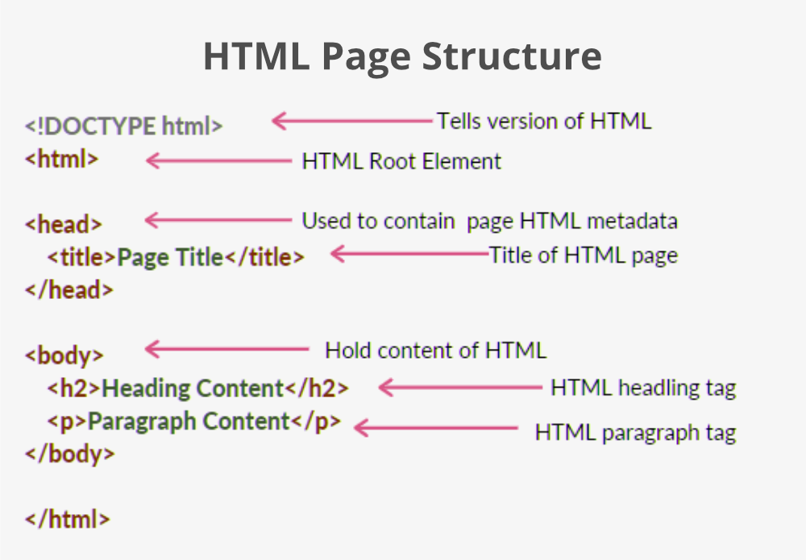

**CSS**

**Cascading Style Sheets** (**CSS**) is a style sheet language used for describing the presentation of a document written in a markup language such as HTML or XML (including XML dialects such as SVG, MathML or XHTML).[[1]](https://en.wikipedia.org/wiki/CSS#cite_note-1) CSS is a cornerstone technology of the World Wide Web, alongside HTML and JavaScript.

CSS is designed to enable the separation of content and presentation, including layout, colours, and fonts.

This separation can improve content accessibility; provide more flexibility and control in the specification of presentation characteristics; enable multiple web pages to share formatting by specifying the relevant CSS in a separate .CSS file, which reduces complexity and repetition in the structural content; and enable the CSS file to be cached to improve the page load speed between the pages that share the file and its formatting.



**XAMPP**

**XAMPP** is a free and open-source cross-platform web server solution stack package developed by Apache Friends, consisting mainly of the Apache HTTP Server, MariaDB database, and interpreters for scripts written in the PHP and Perl programming languages. Since most actual web server deployments use the same components as XAMPP, it makes transitioning from a local test server to a live server possible.



**WEB BROWSER**

A **web browser** is an application for accessing websites. When a user requests a web page from a particular website, the browser retrieves its files from a web server and then displays the page on the user's screen. Browsers are used on a range of devices, including desktops, laptops, tablets, and smartphones.

In 2020, an estimated 4.9 billion people have used a browser.[[1]](https://en.wikipedia.org/wiki/Web_browser#cite_note-1) The most used browser is Google Chrome, with a 65% global market share on all devices, followed by Safari with 18%.

  

* **Limitations**

**Limited Menu Options: The website may not include the complete menu of the college canteen, which can limit the choices available to users.**

**Dependence on User Input: The website may rely on users to provide feedback and suggestions for menu items and improvements, which can lead to limited and biased input.**

**Inaccurate Availability Information: The website may not always reflect the accurate availability of menu items, leading to disappointment and frustration for users who expect a certain item to be available.**

**Technical Issues: The website may experience technical issues, such as slow loading times, broken links, and errors, which can negatively impact the user experience.**

**Limited Payment Options: The website may only accept certain payment options, such as cash or card, which may not be convenient for all users.**

**Lack of Personalization: The website may not offer personalized options for users with dietary restrictions or preferences, such as vegetarian or gluten-free options.**

**Limited User Interaction: The website may not provide opportunities for users to interact with each other or provide feedback on menu items, limiting the sense of community around the canteen.**

* **Advantages**

**A college canteen ordering website would bring many advantages to both students and the canteen staff. With the help of such a website, students would be able to place their orders online and select the food that they want to have, instead of waiting in long queues at the canteen.**

**[1] This would also benefit the canteen staff, as the system would handle everything, making it easier and more efficient to process orders.**

**[2] The website would also help in reducing the time and effort required for making cash transactions, as an electronic payment method would be used.**

**[3] With the implementation of such a system, students would be able to order food from anywhere and at any time, and the canteen staff would be able to manage orders more effectively**

* **Data Flow Diagram**

**Level 0**

**User**

**|**

**------------------------------**

**| |**

**Order Food Manage Canteen**

**LEVEL-1**

**User**

**|**

**---------------**

**| |**

**Menu        Cart**

**User**

**|**

**---------------**

**| |**

**Add Menu    Update Menu**

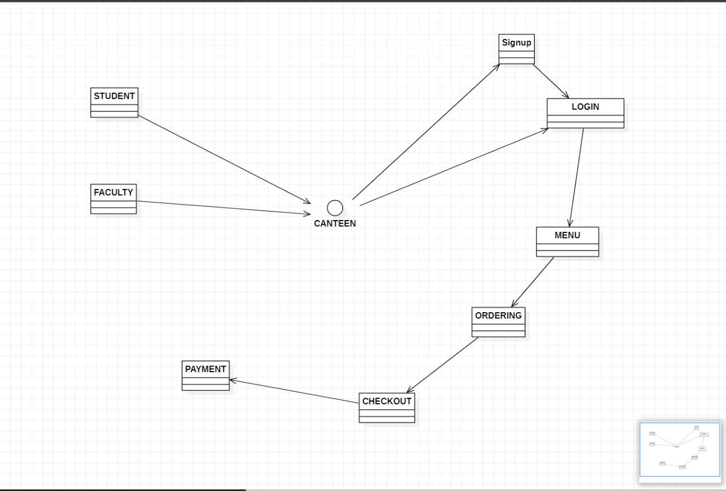

* **Input / Output Code and Images**

1. **LOGIN PAGE**

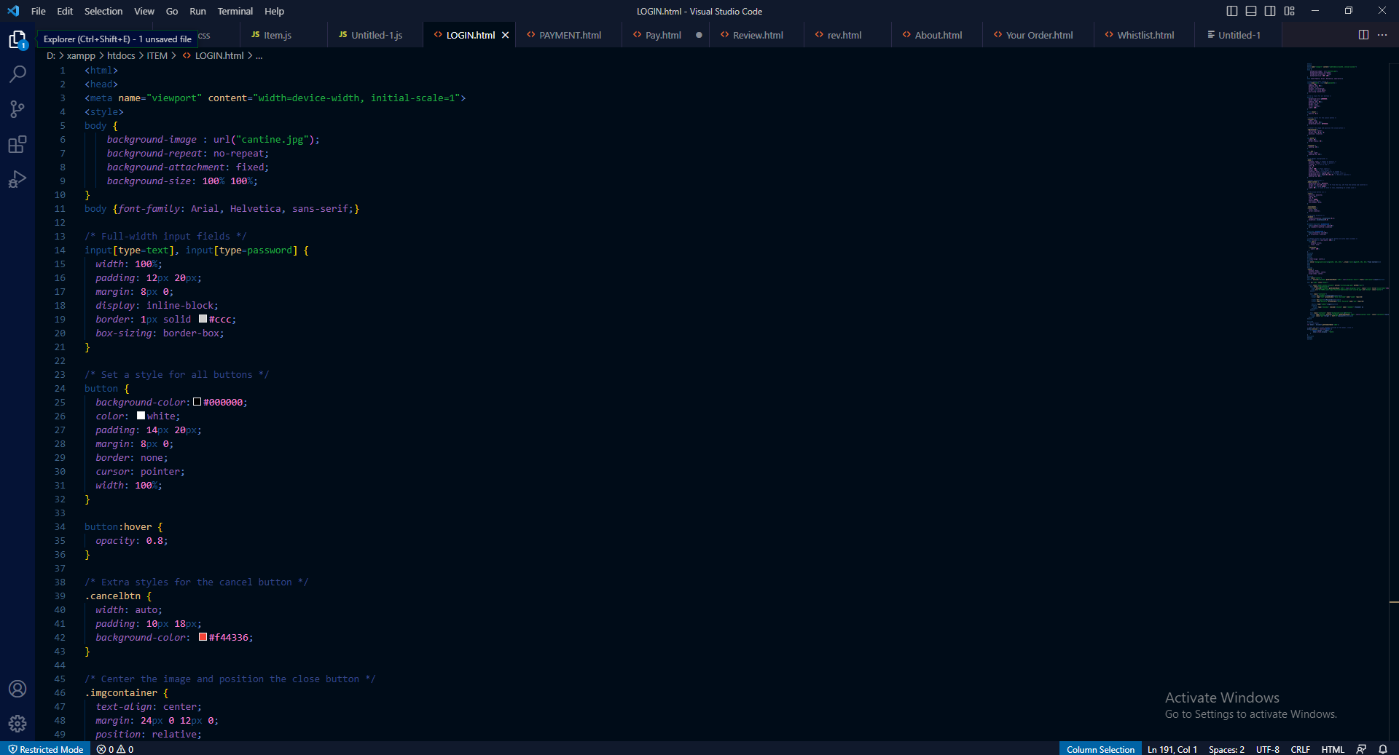

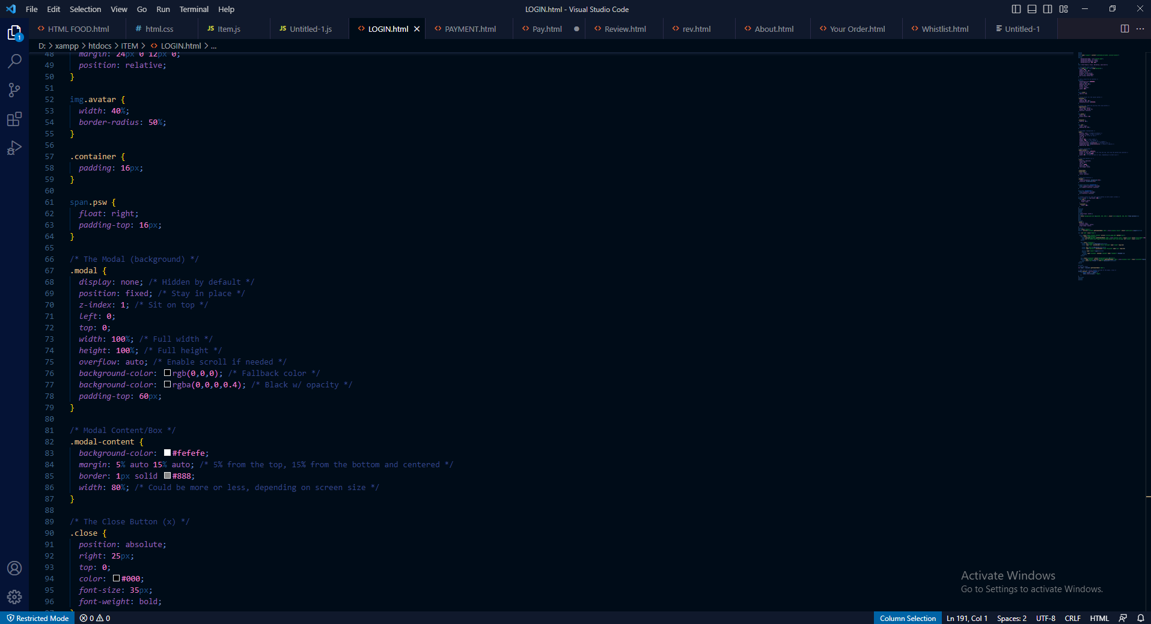

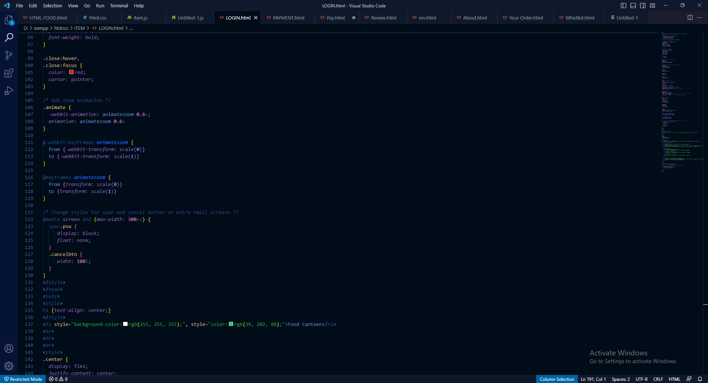

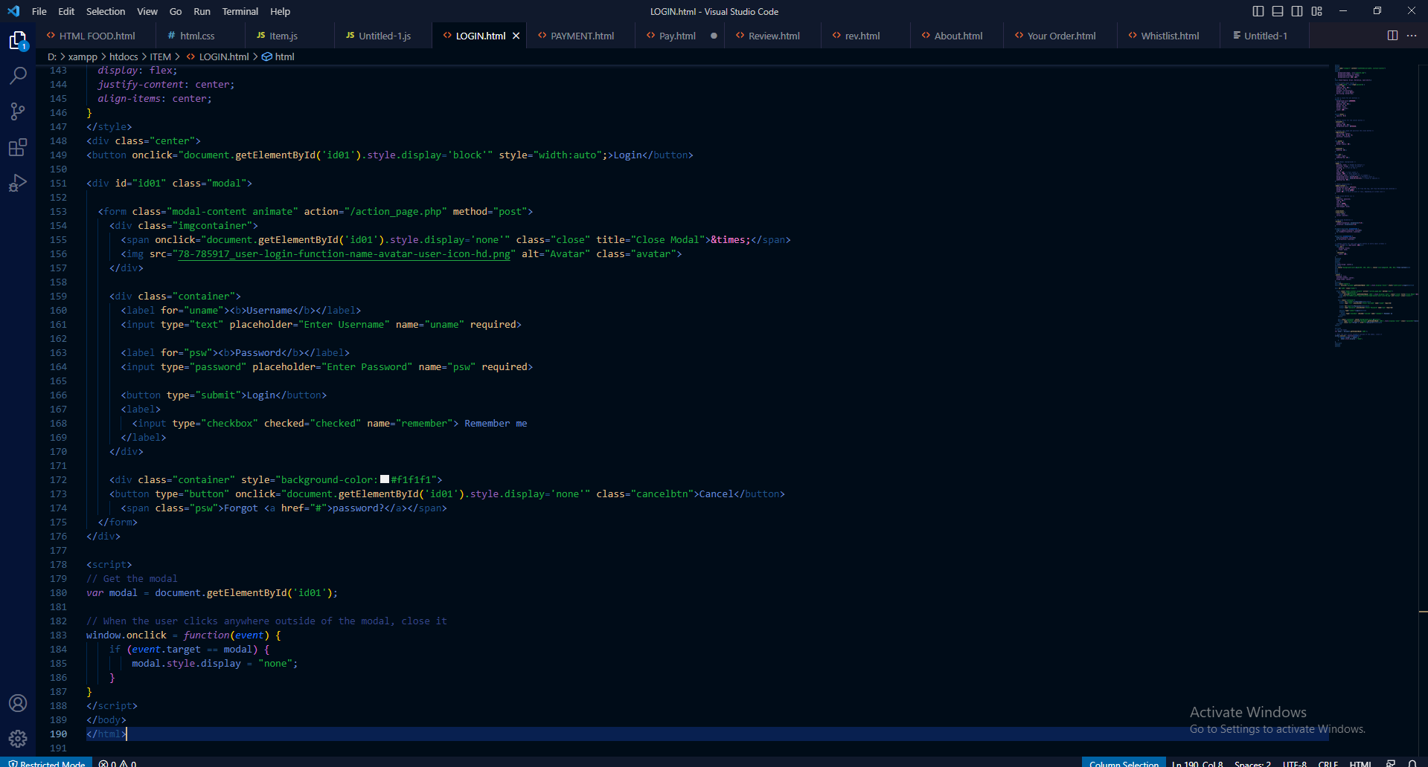

**LOGIN OUTPUT**

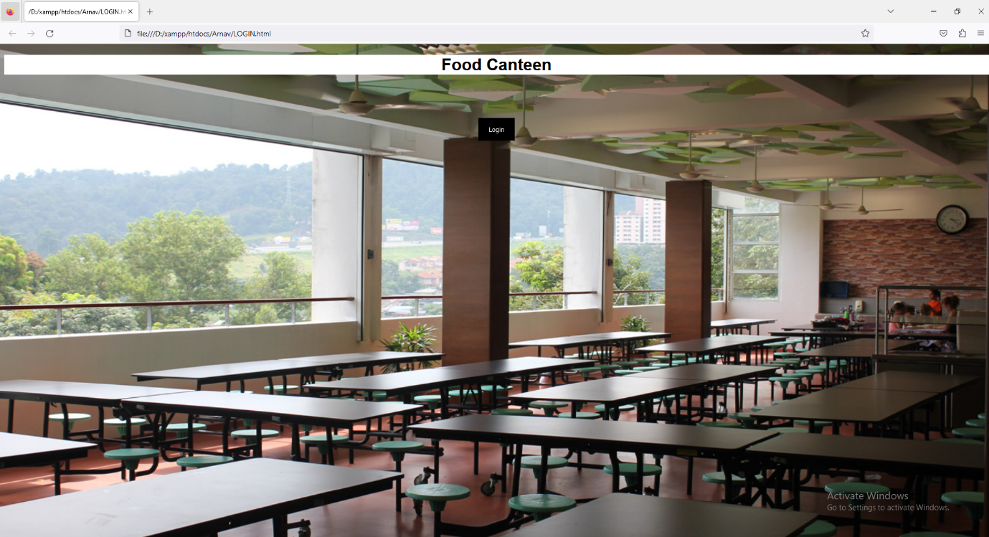

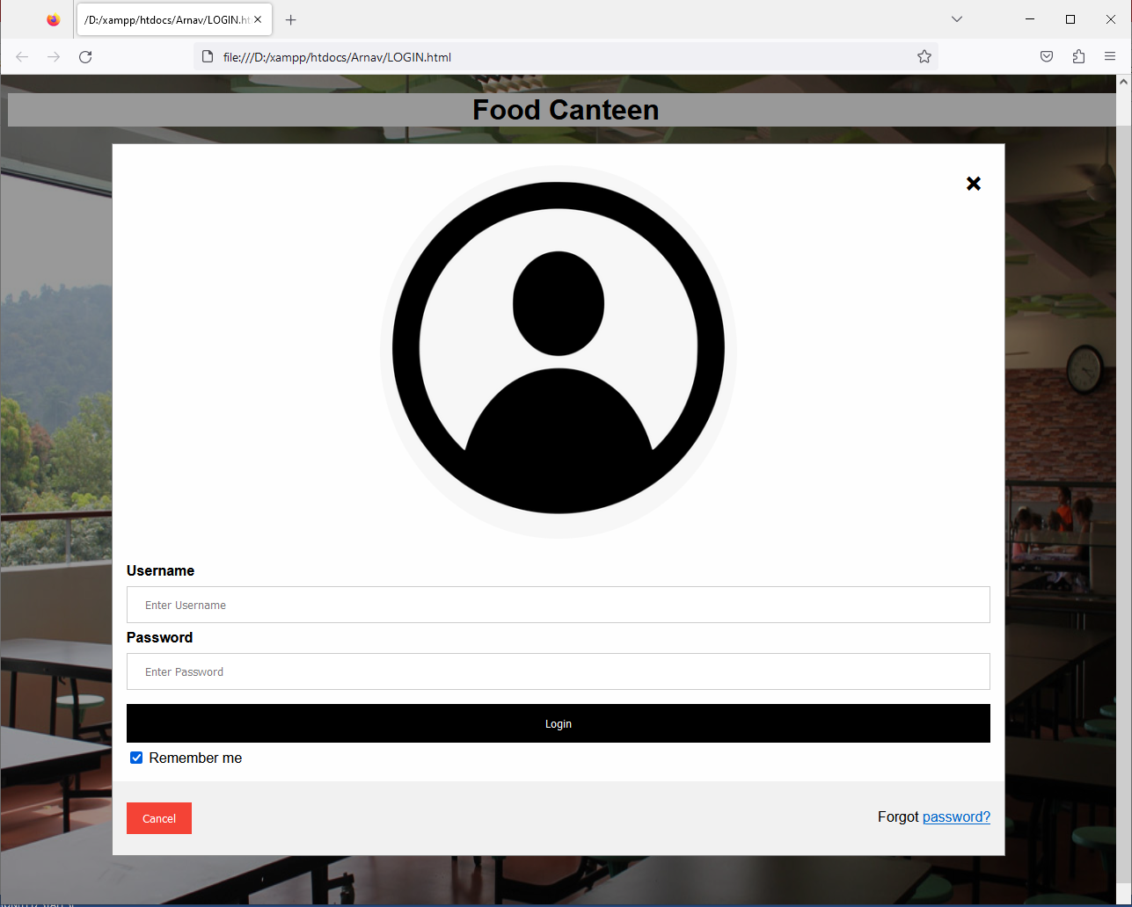

**Payment**

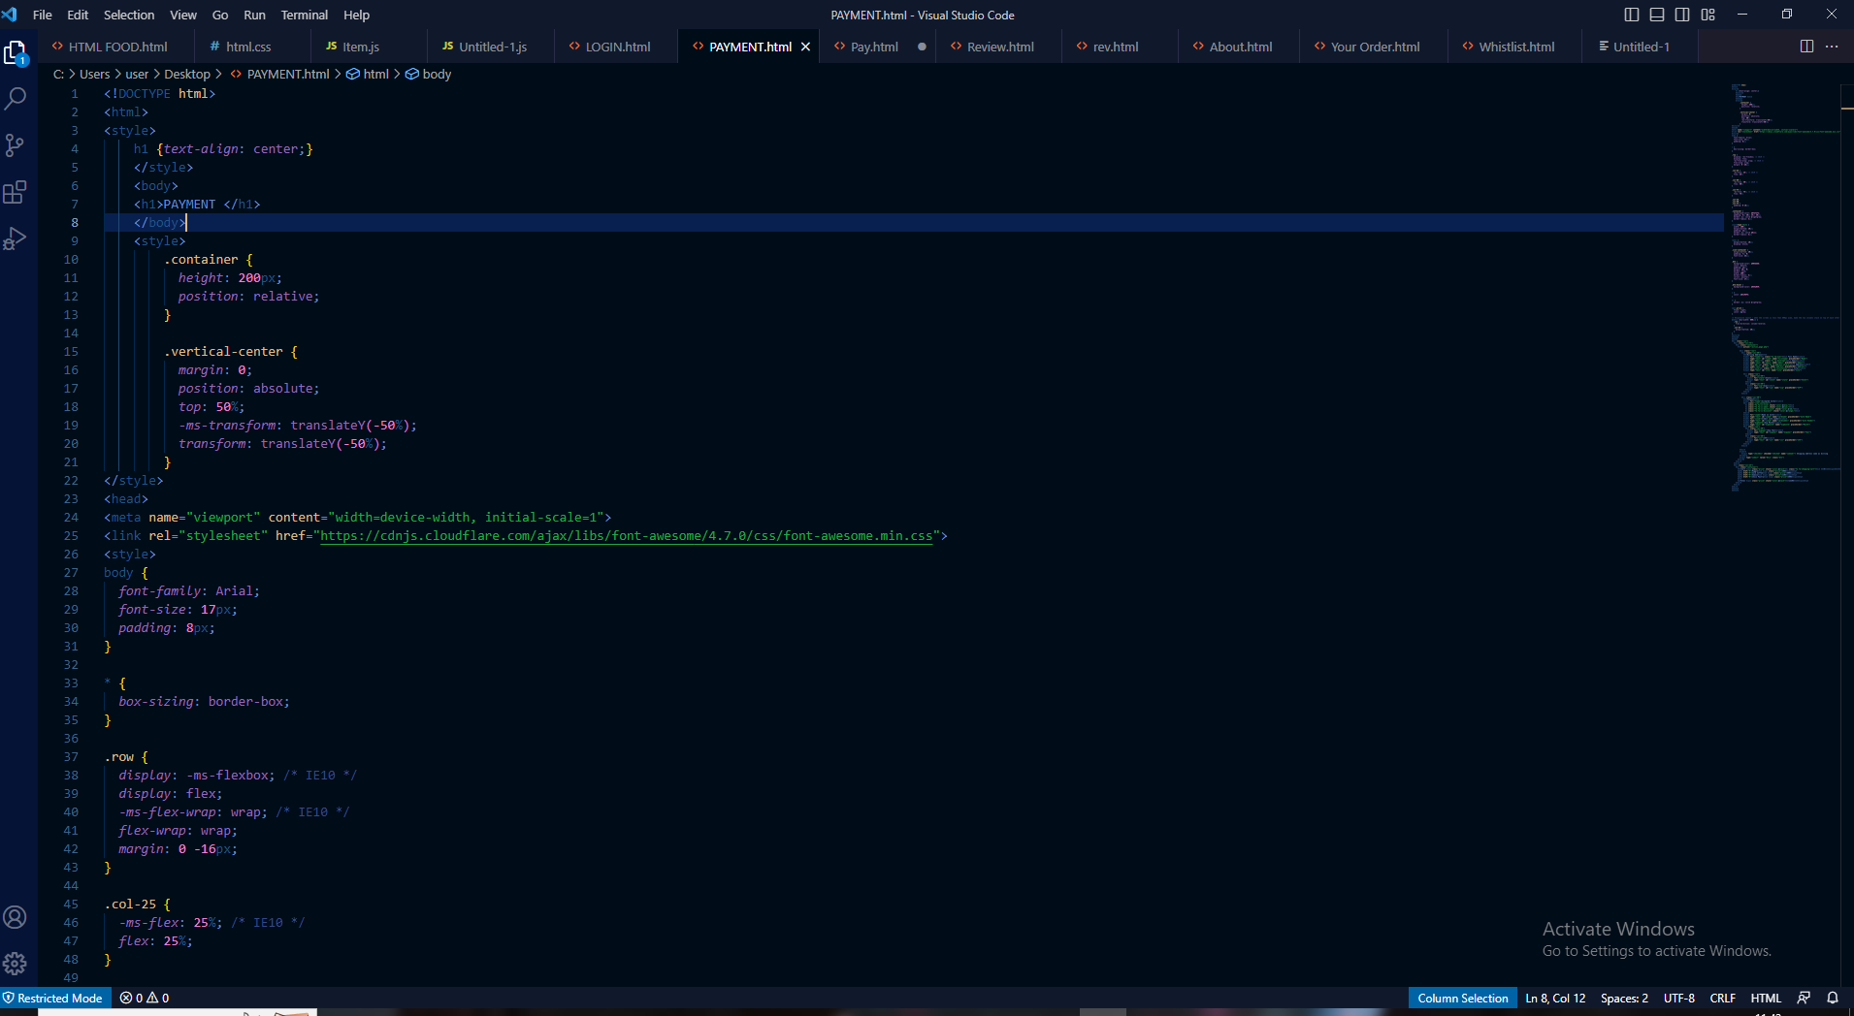

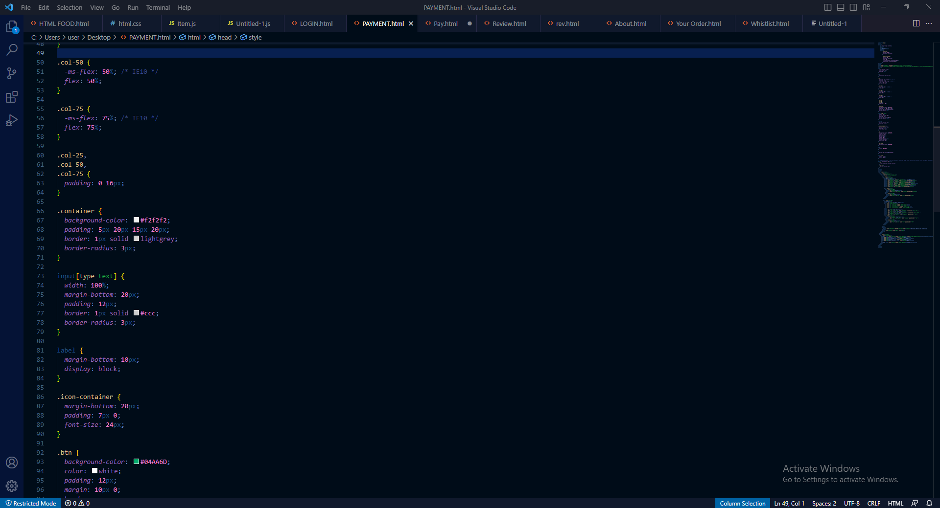

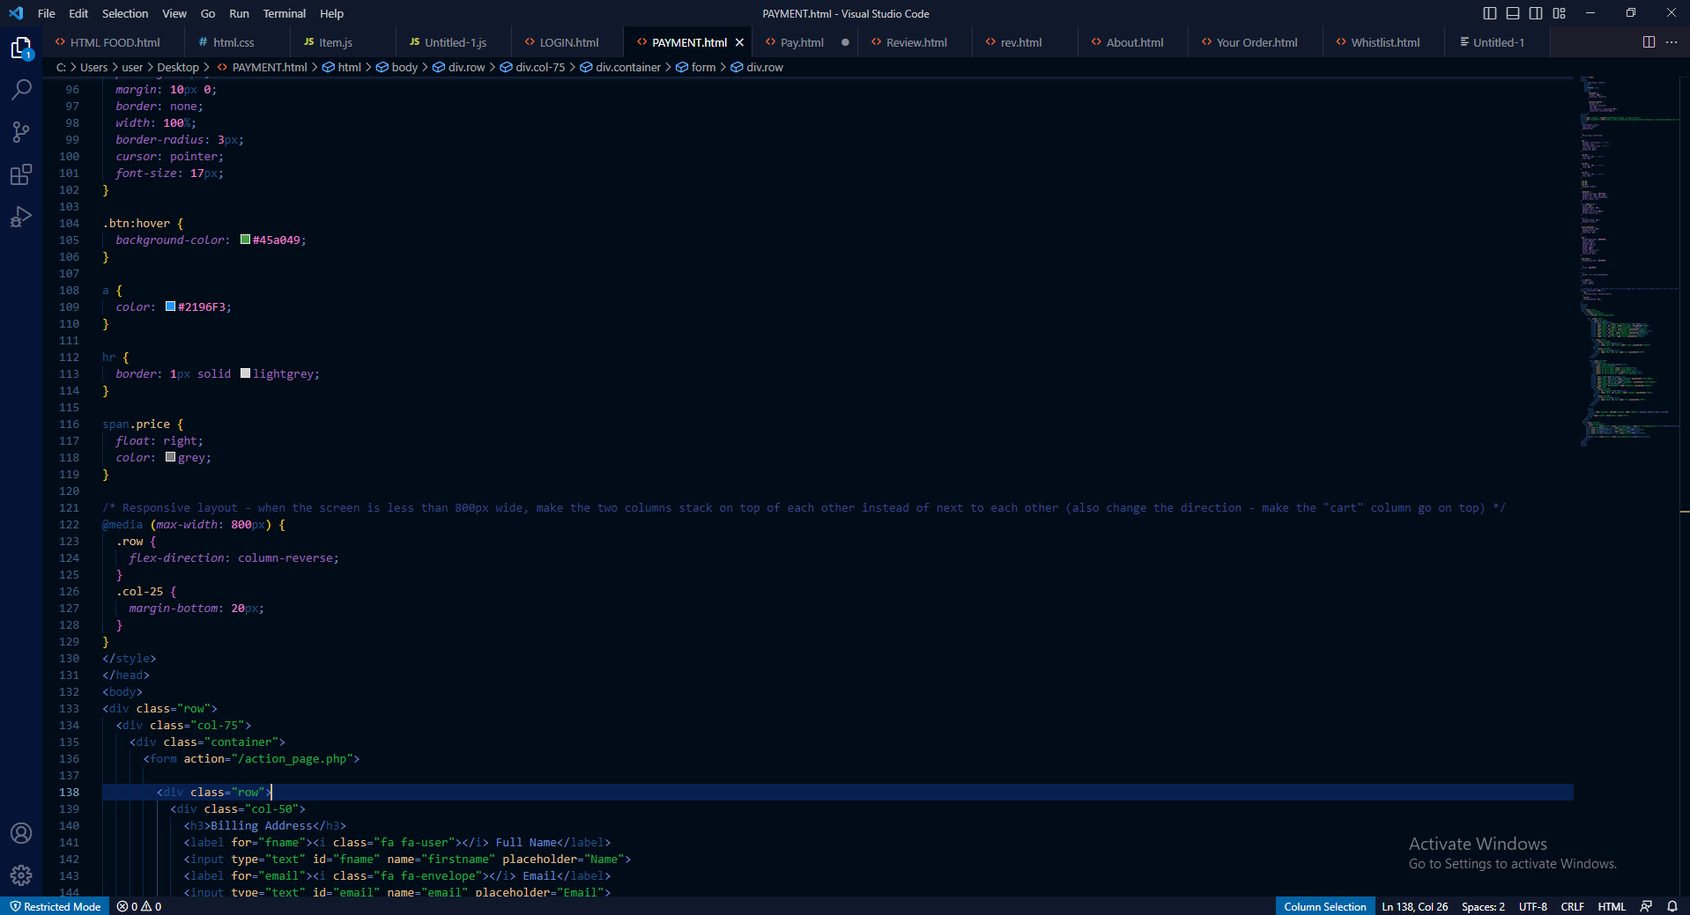

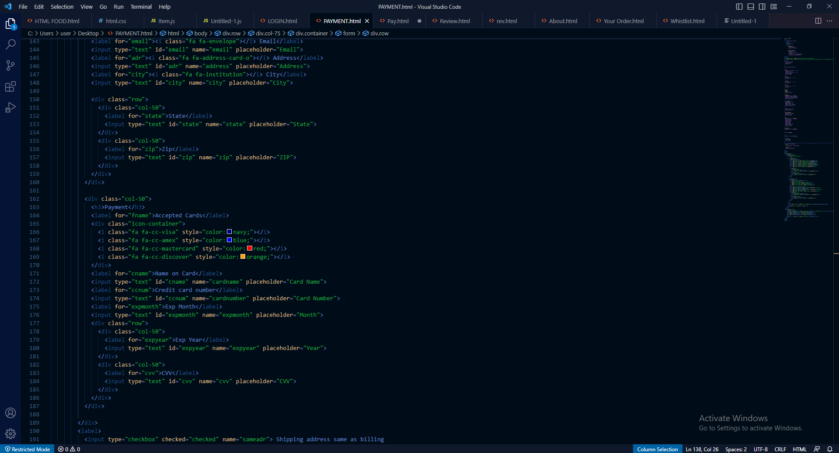

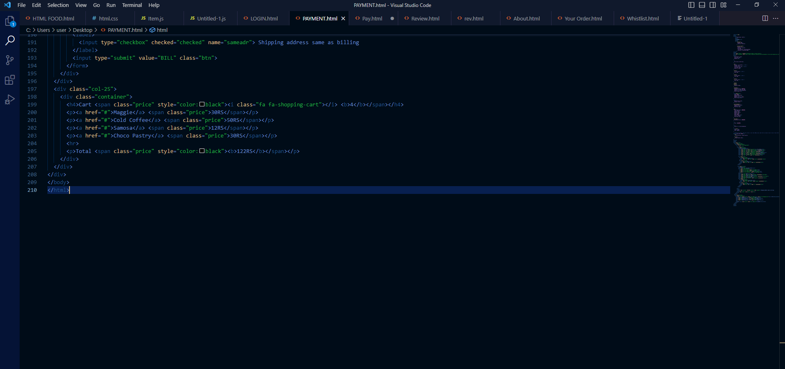

**PAY**

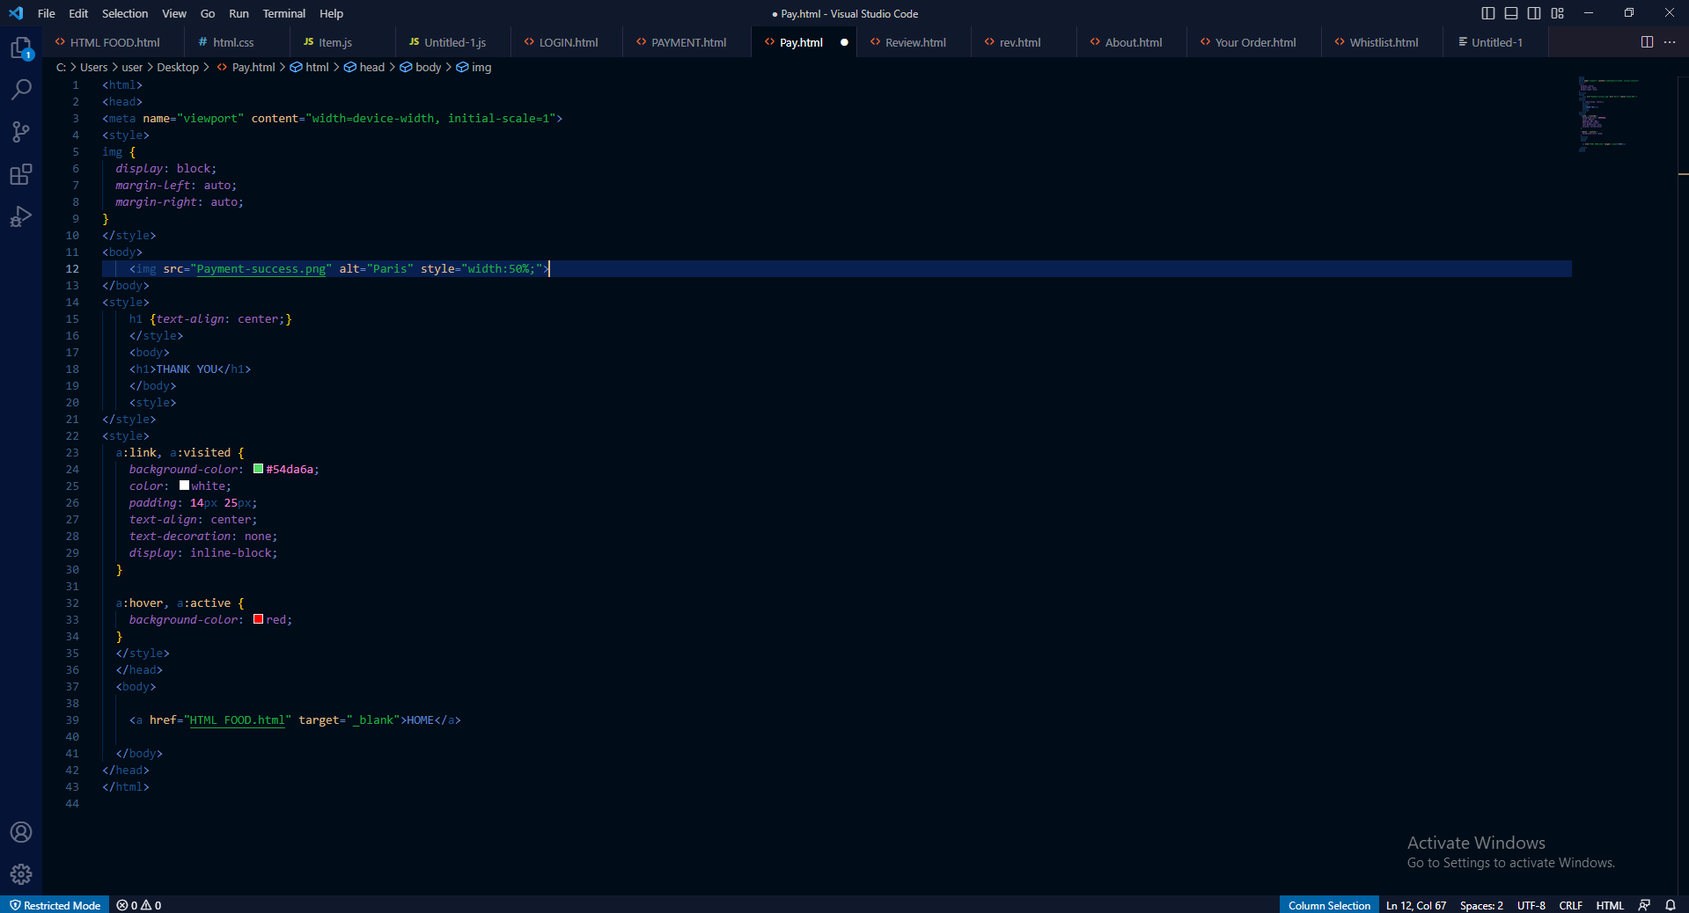

**OUTPUT PAYMENT**

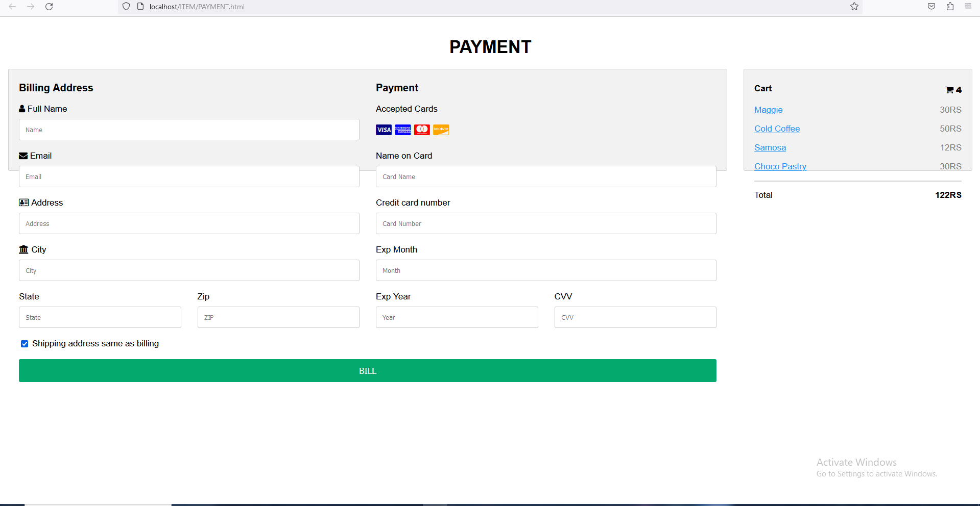

**PAY**

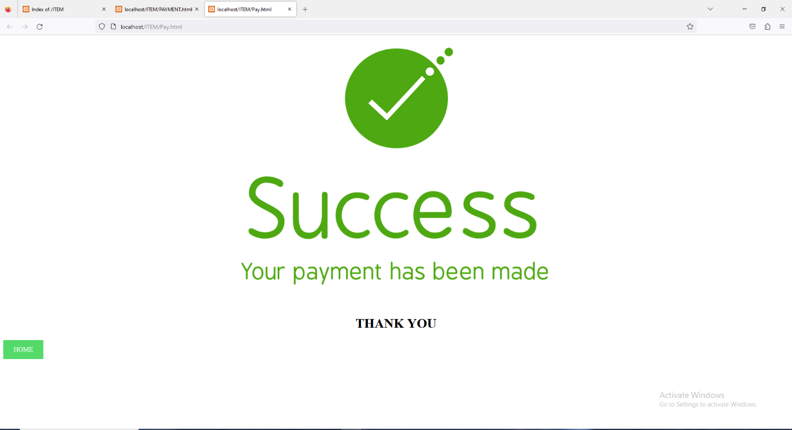

**XAMPP**

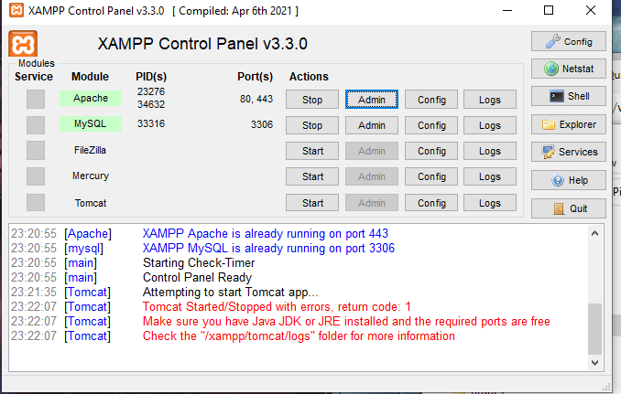

**HTML UI**

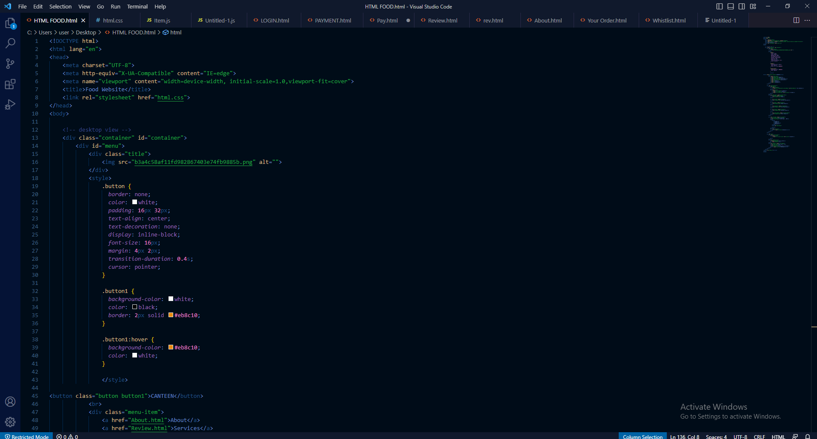

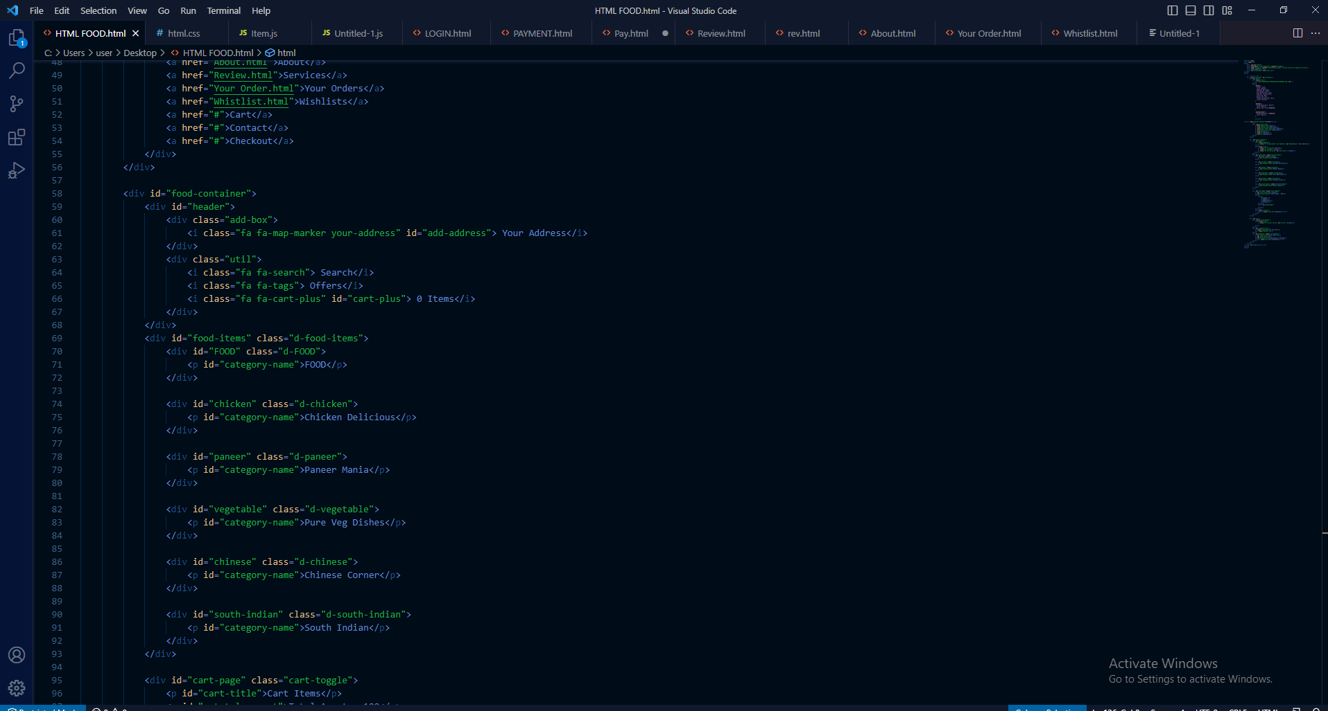

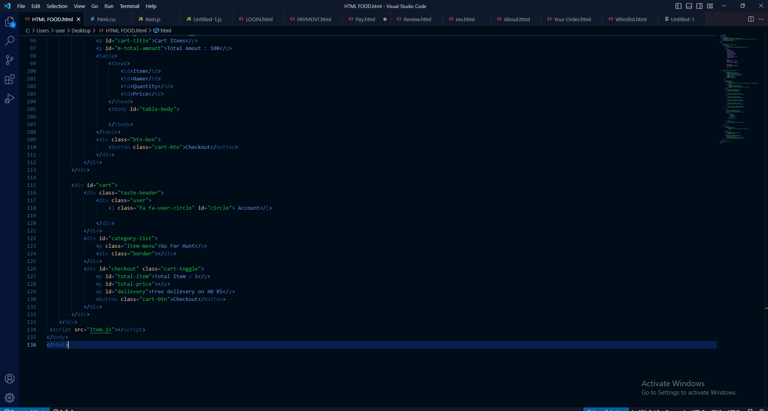

**CSS**

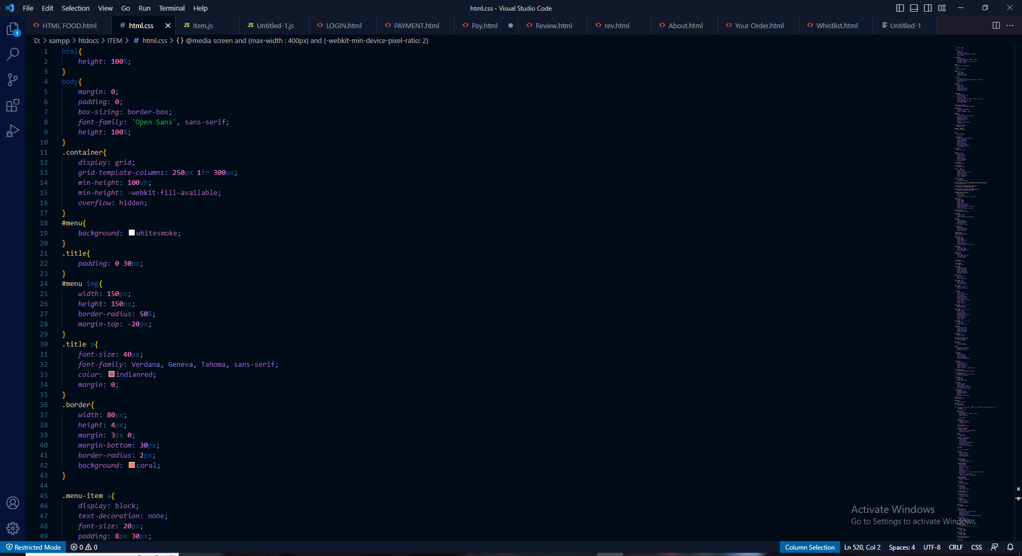

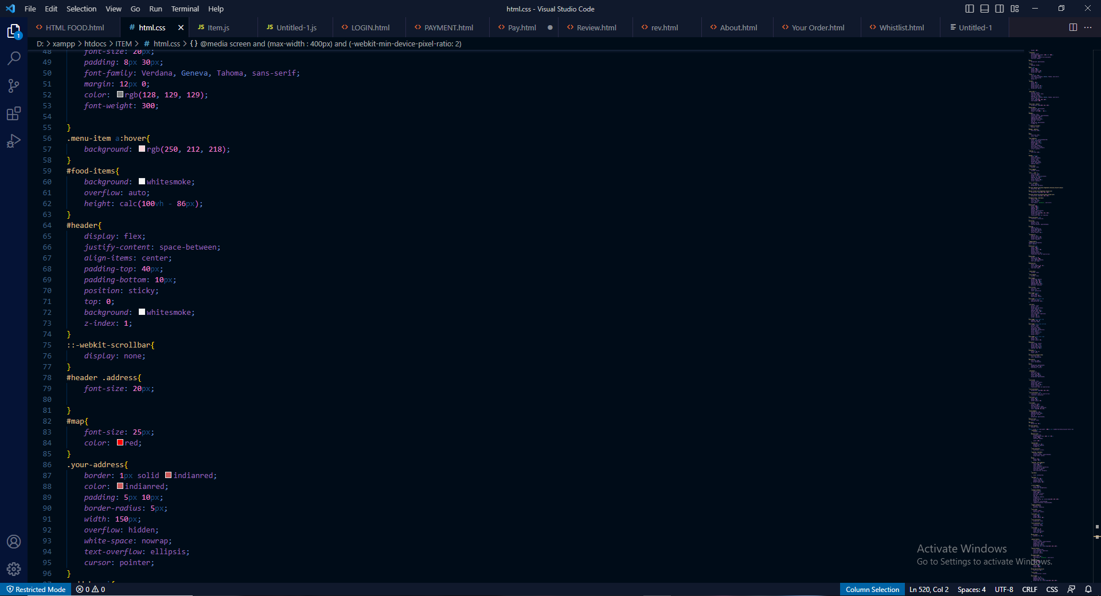

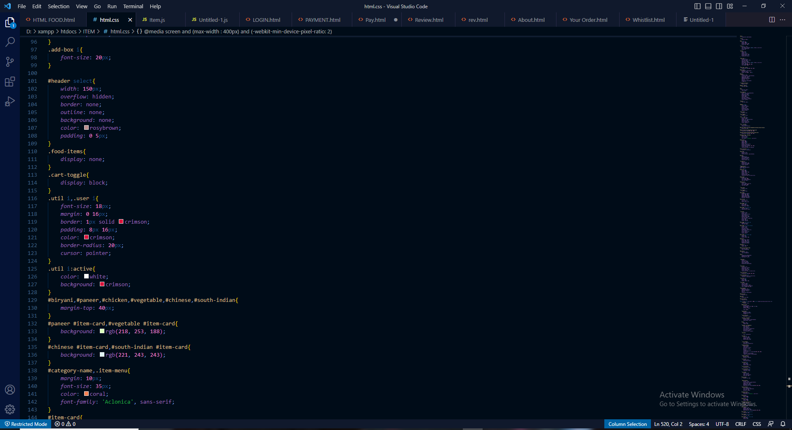

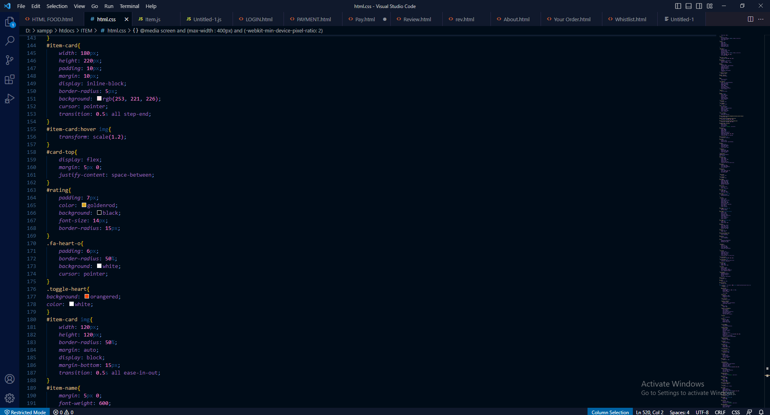

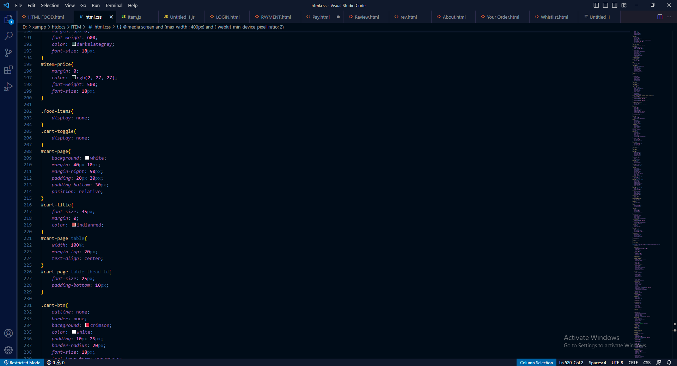

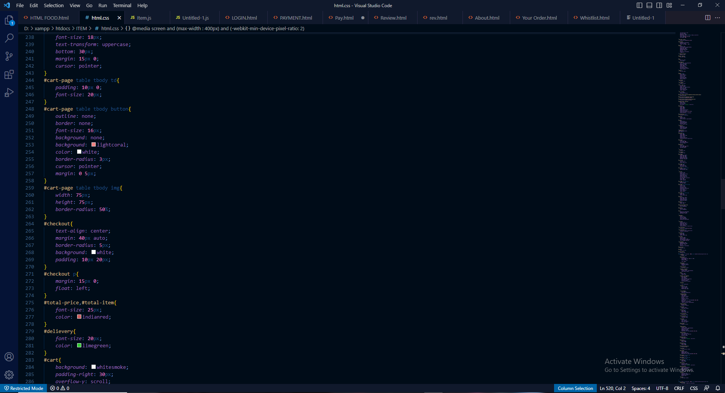

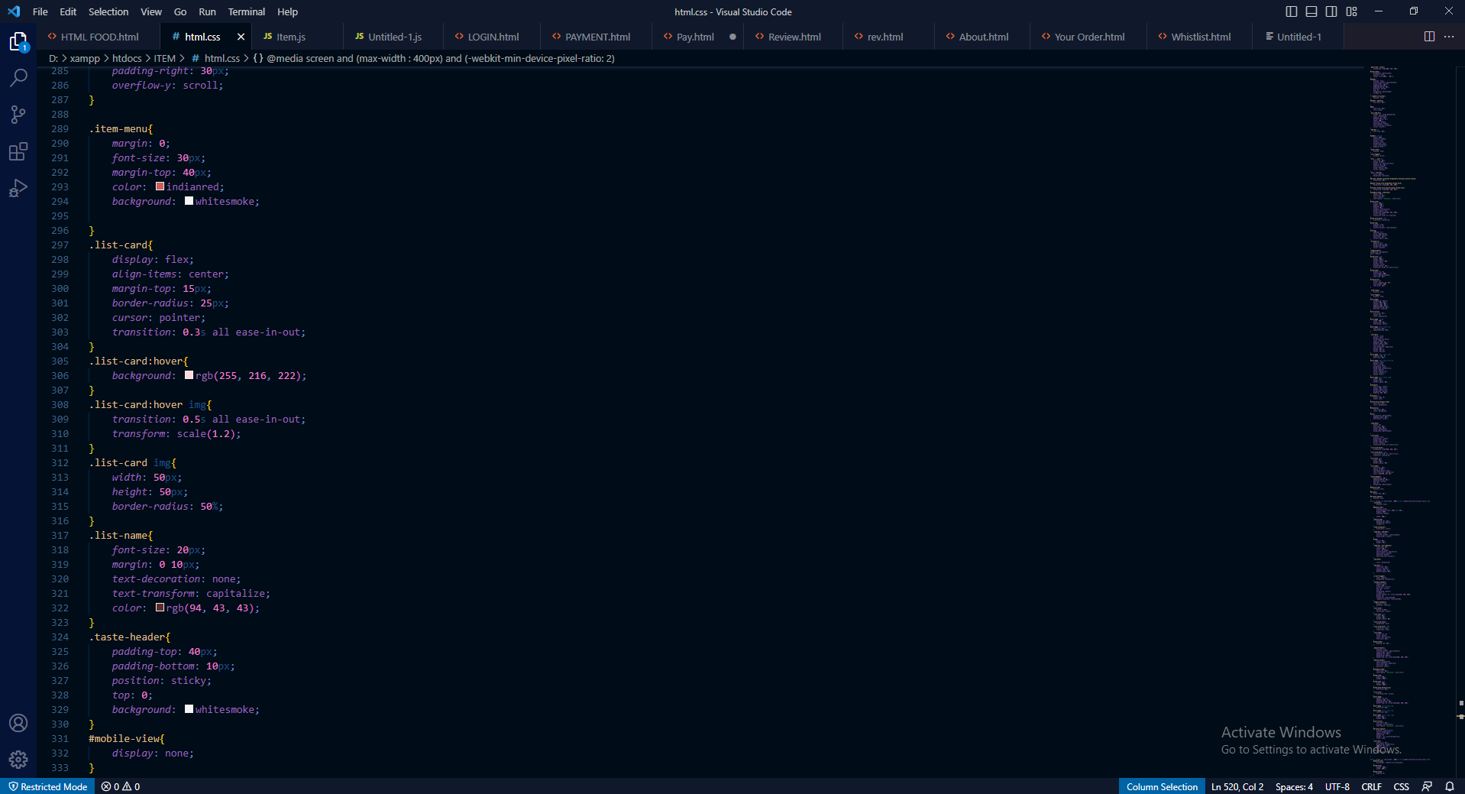

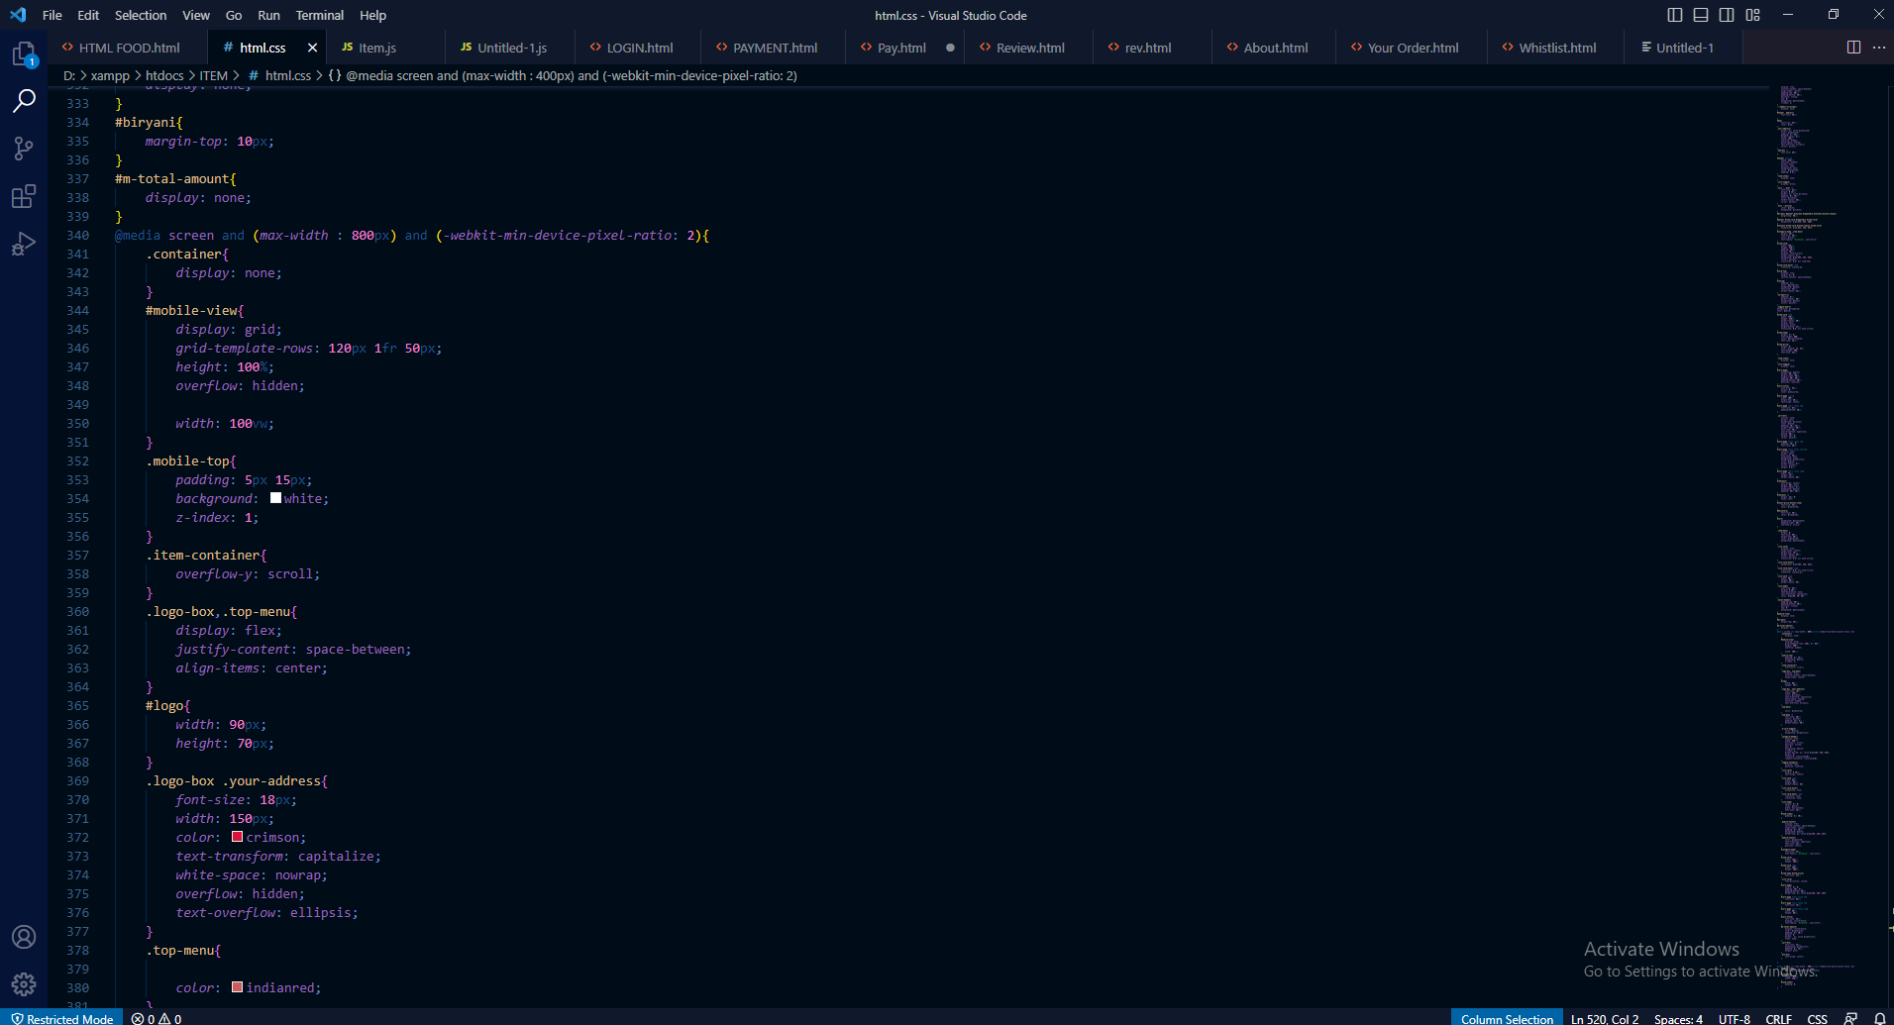

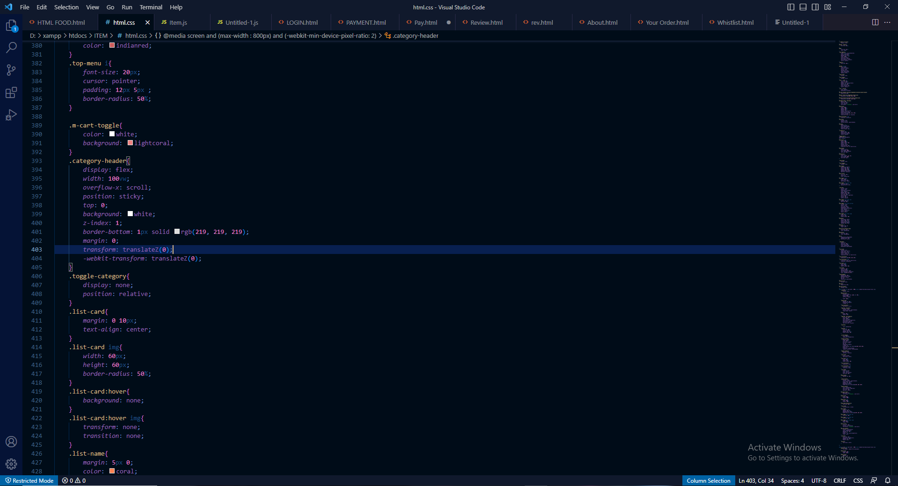

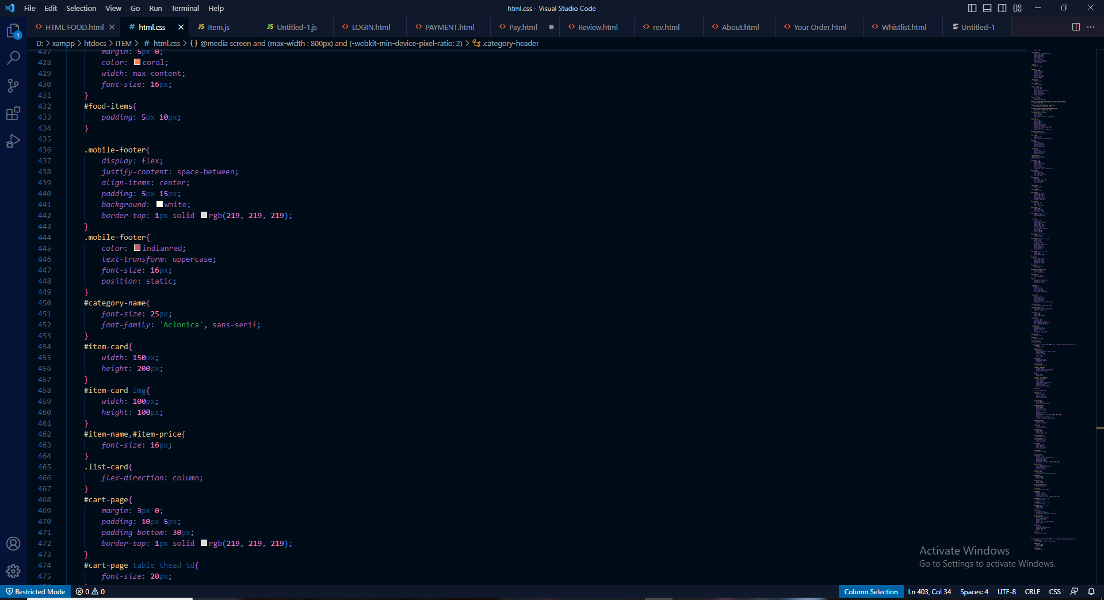

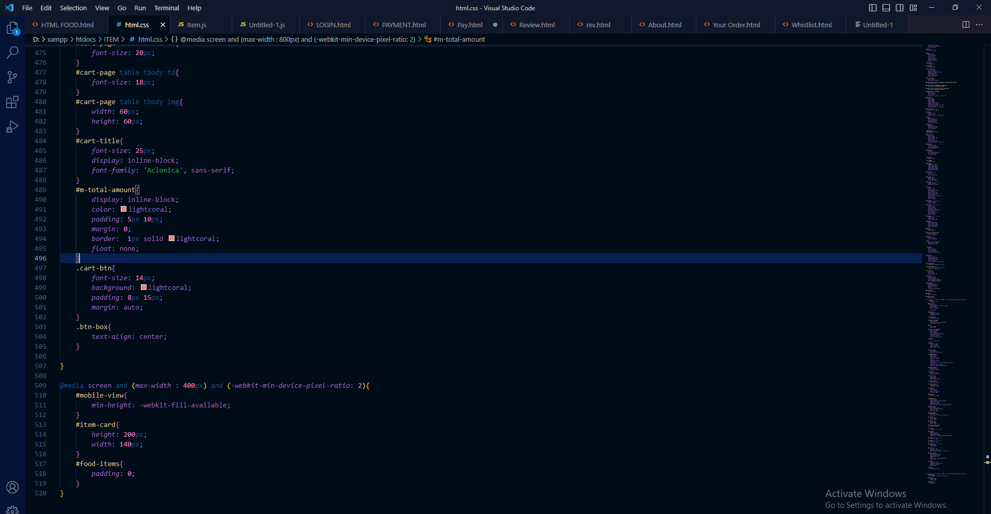

**ITEM JAVA SCRIPT**

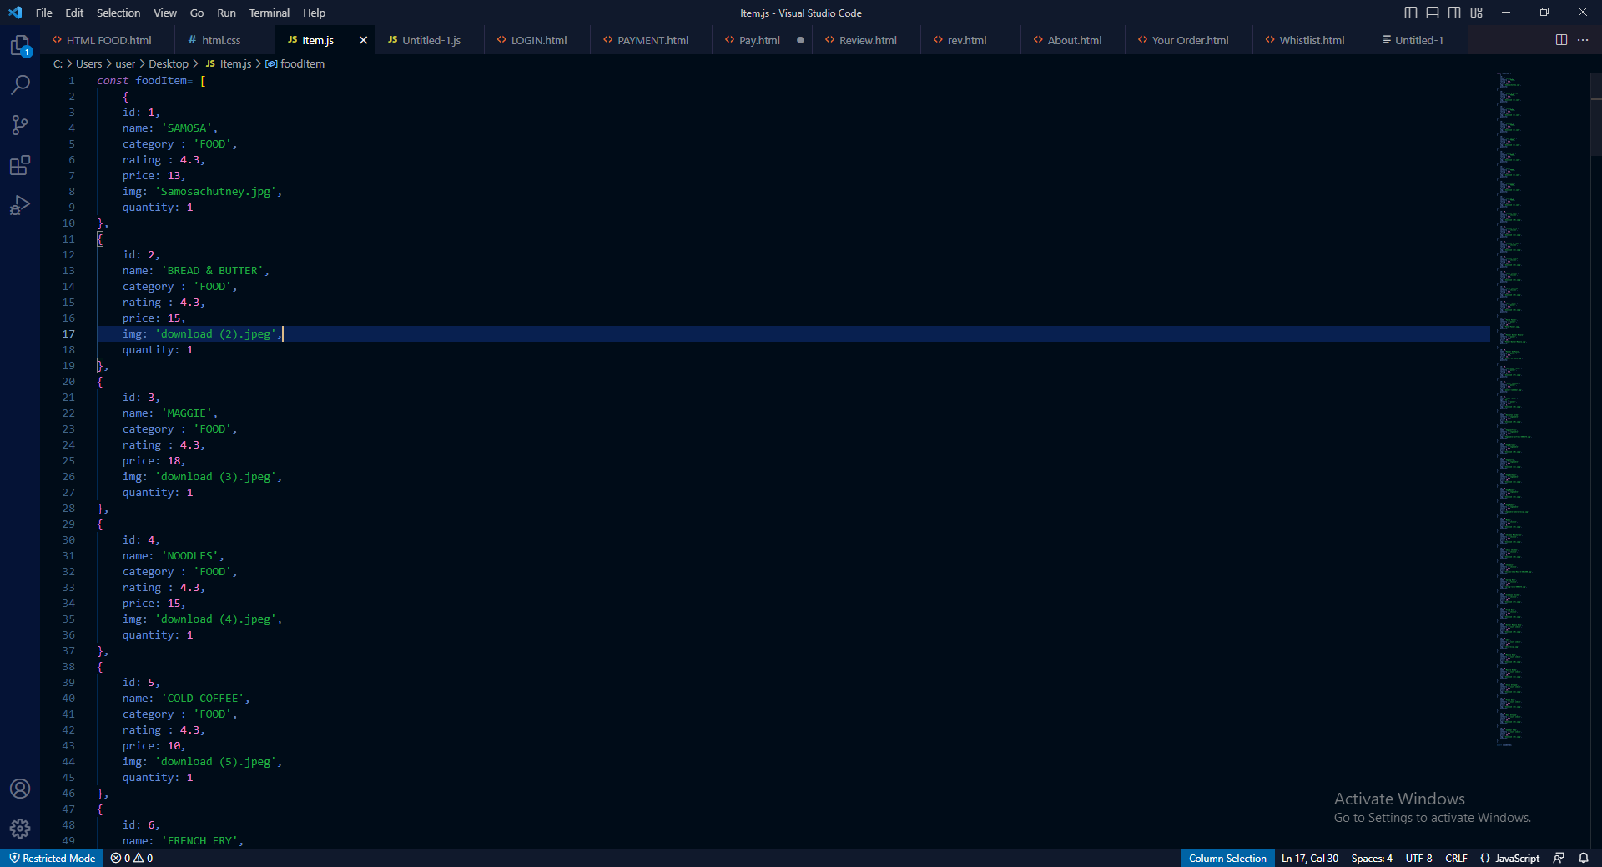

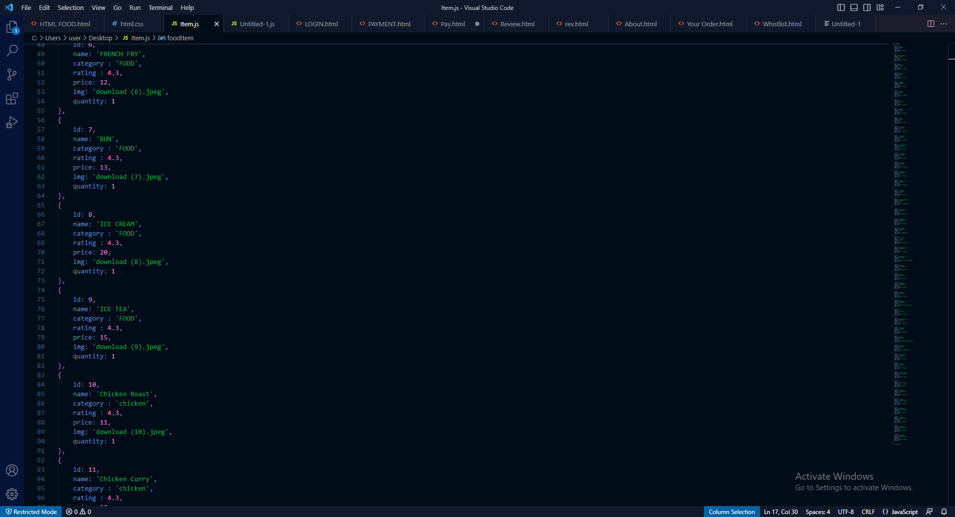

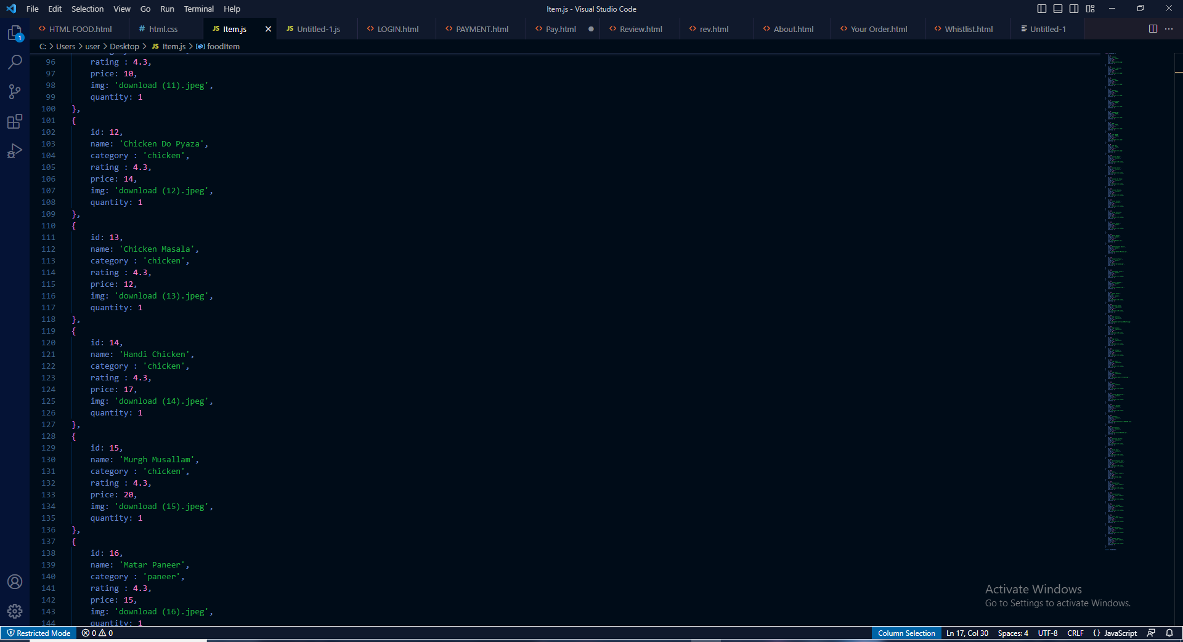

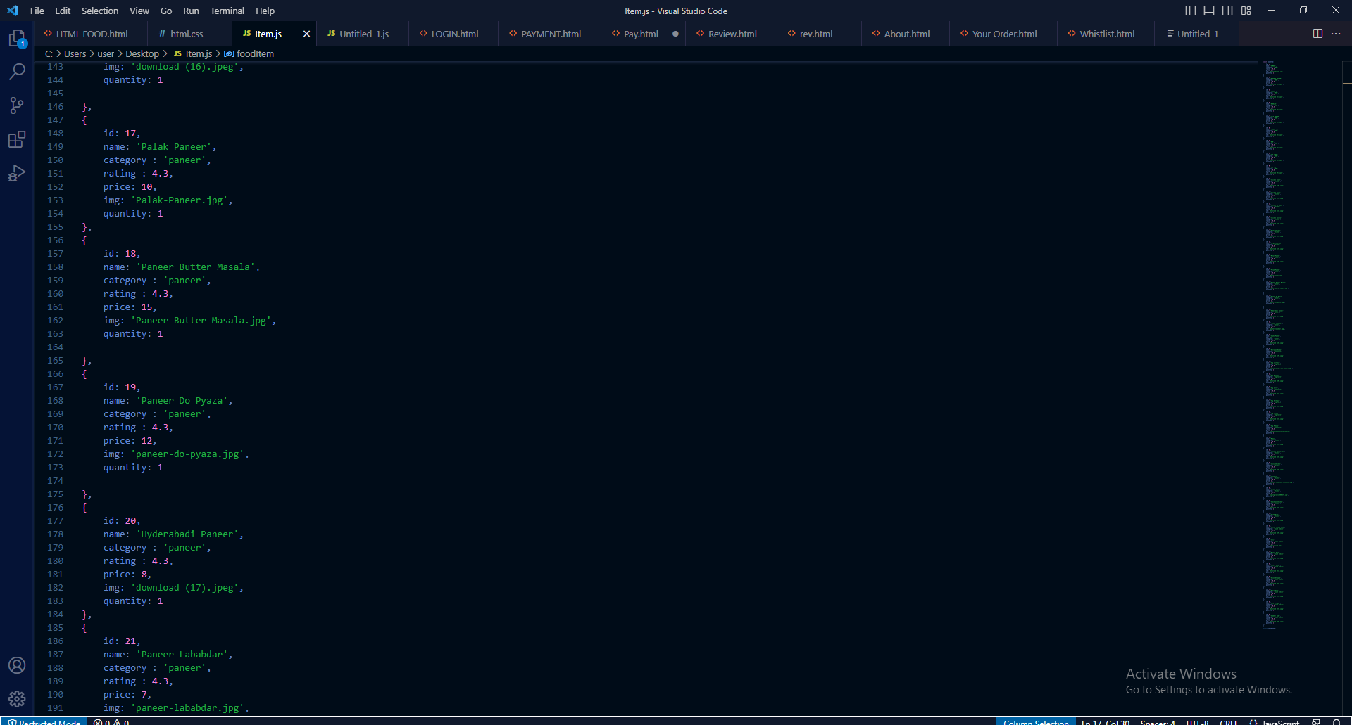

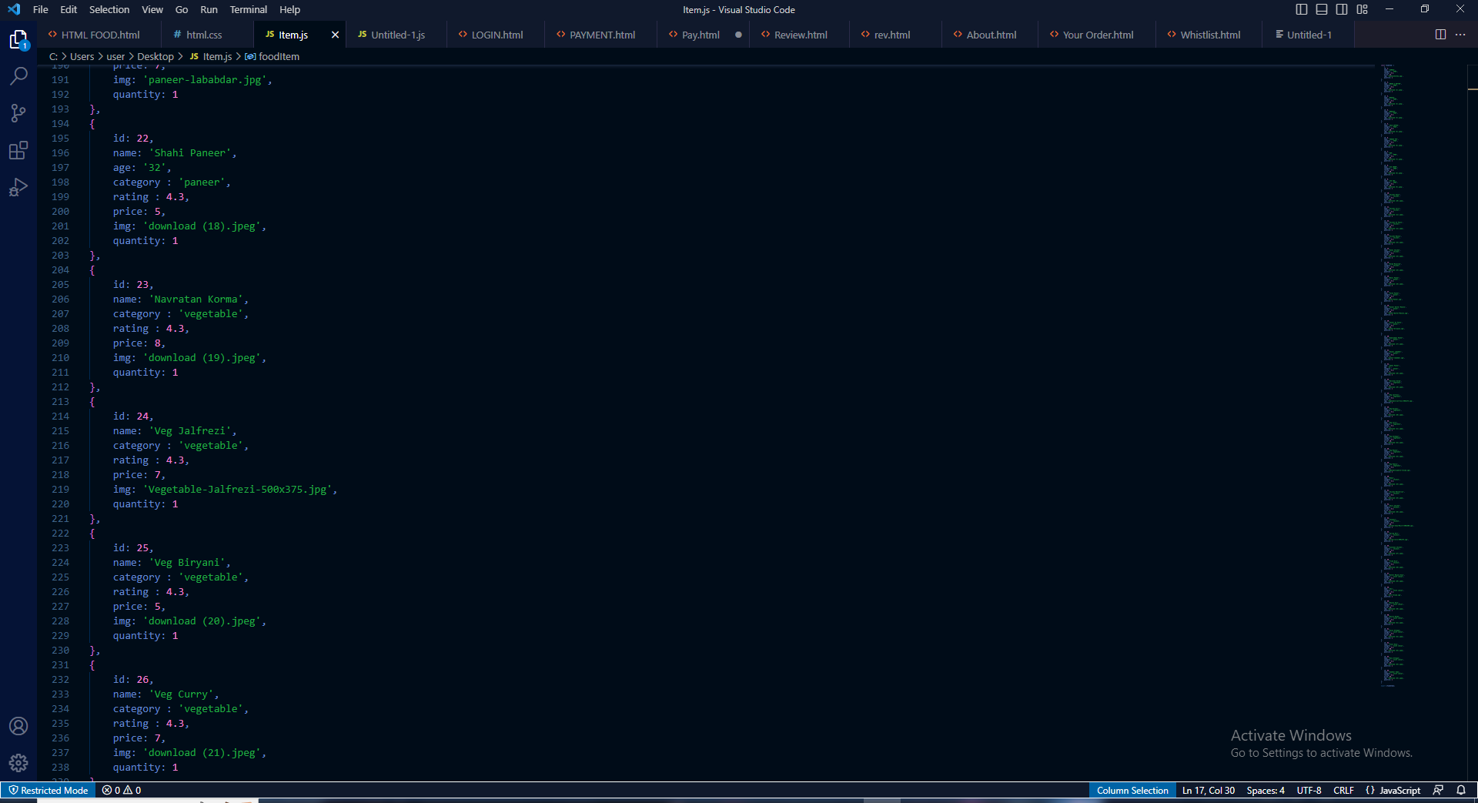

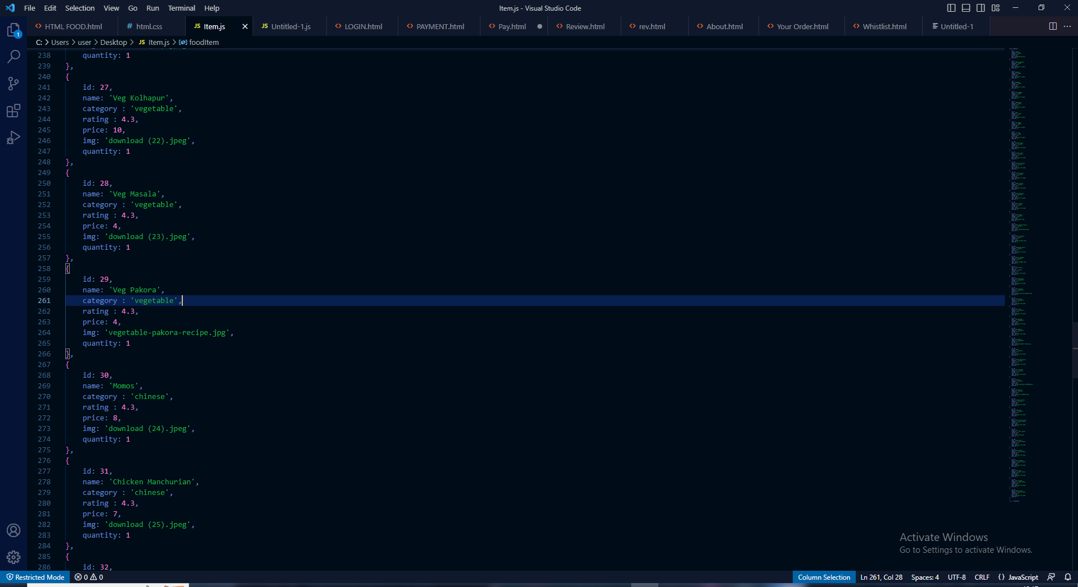

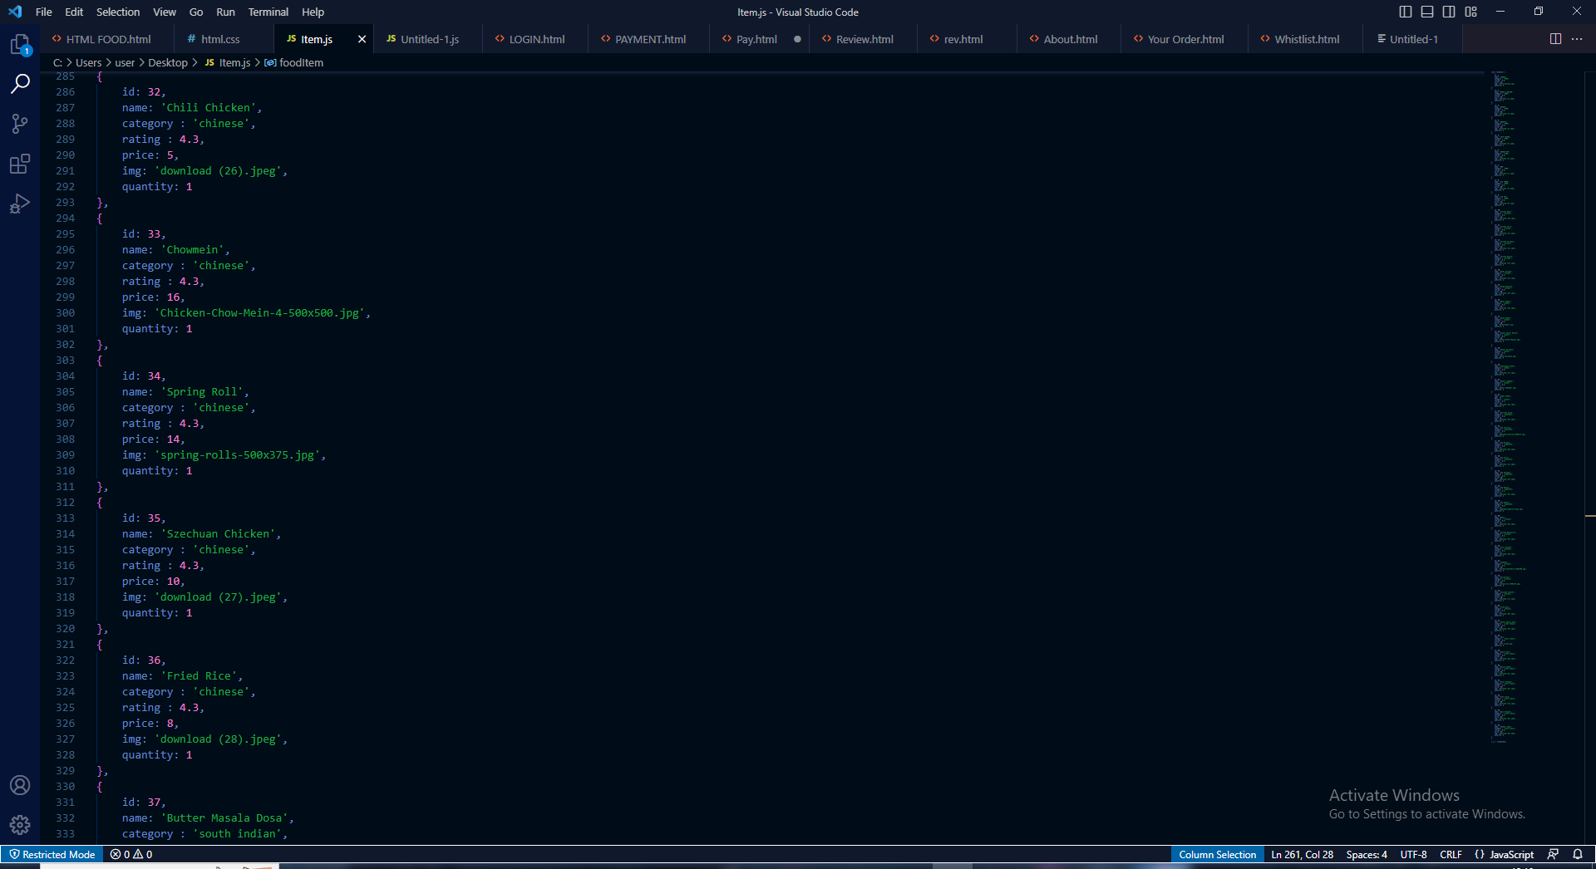

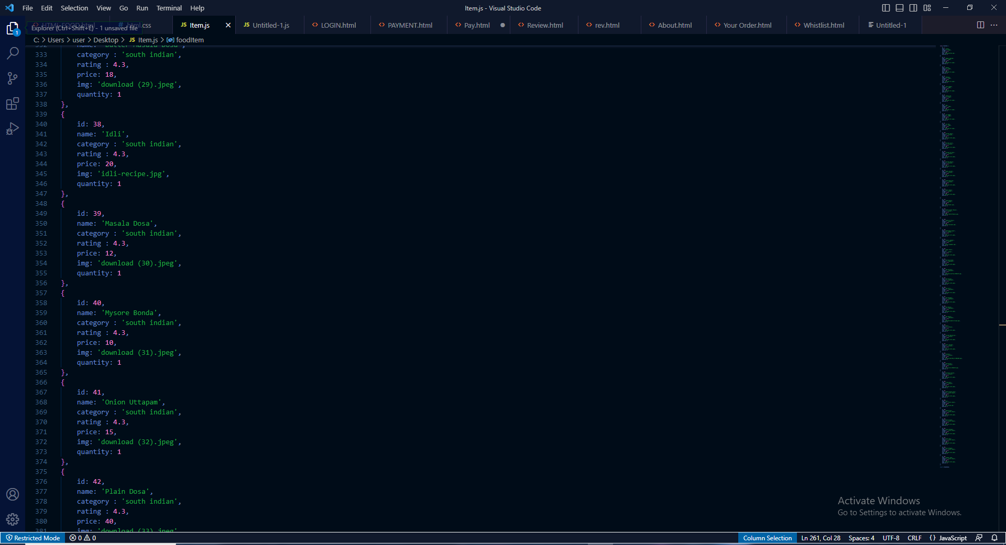

**Java Script**

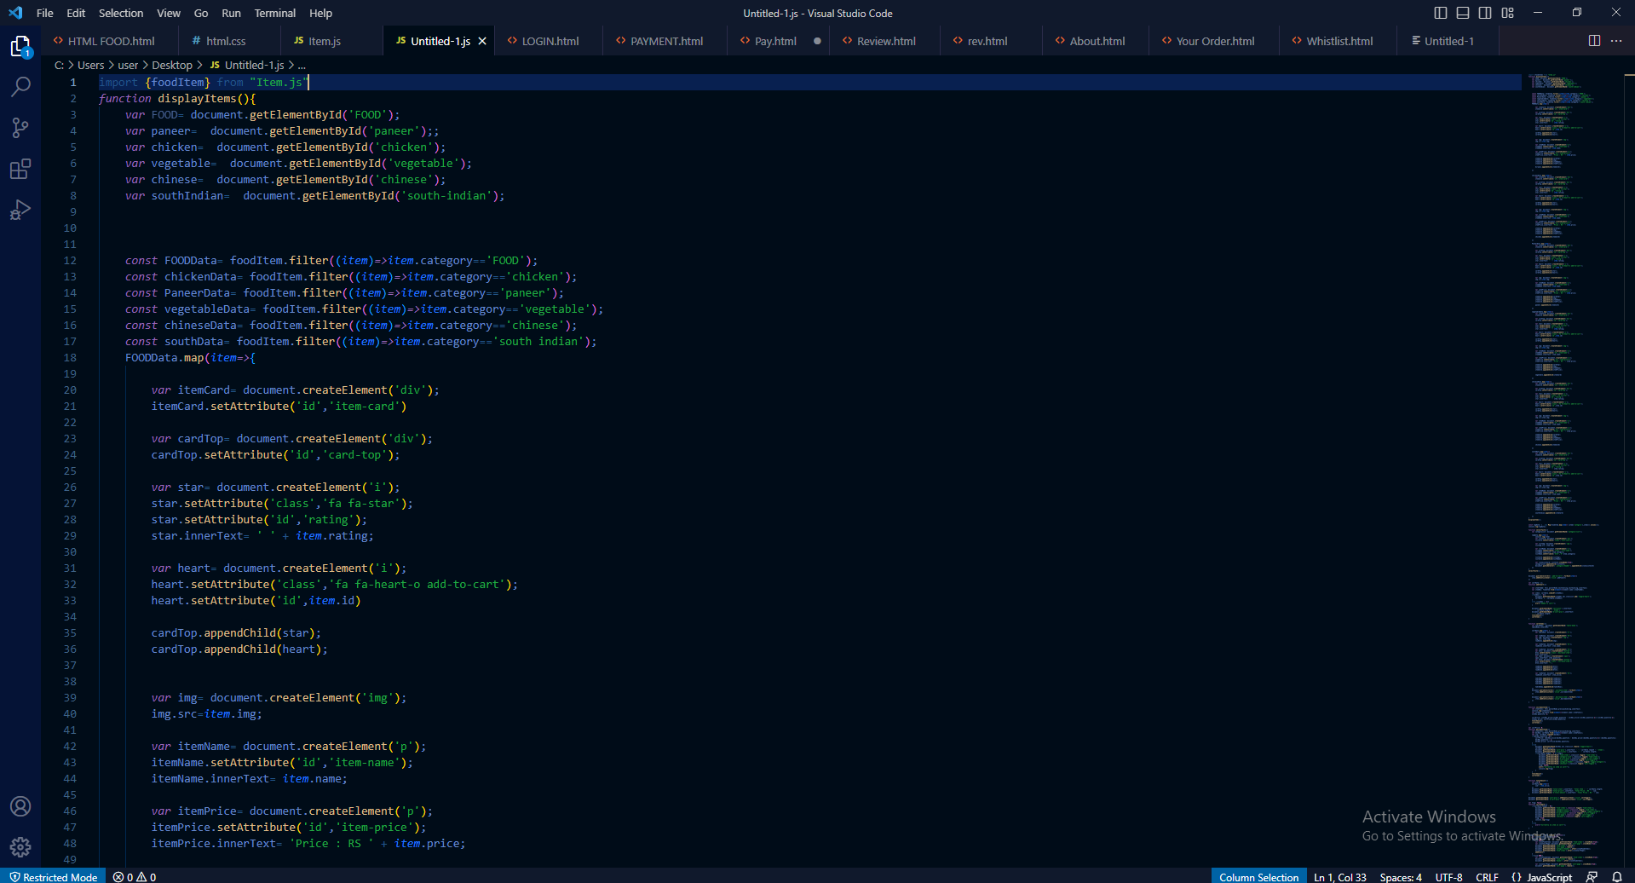

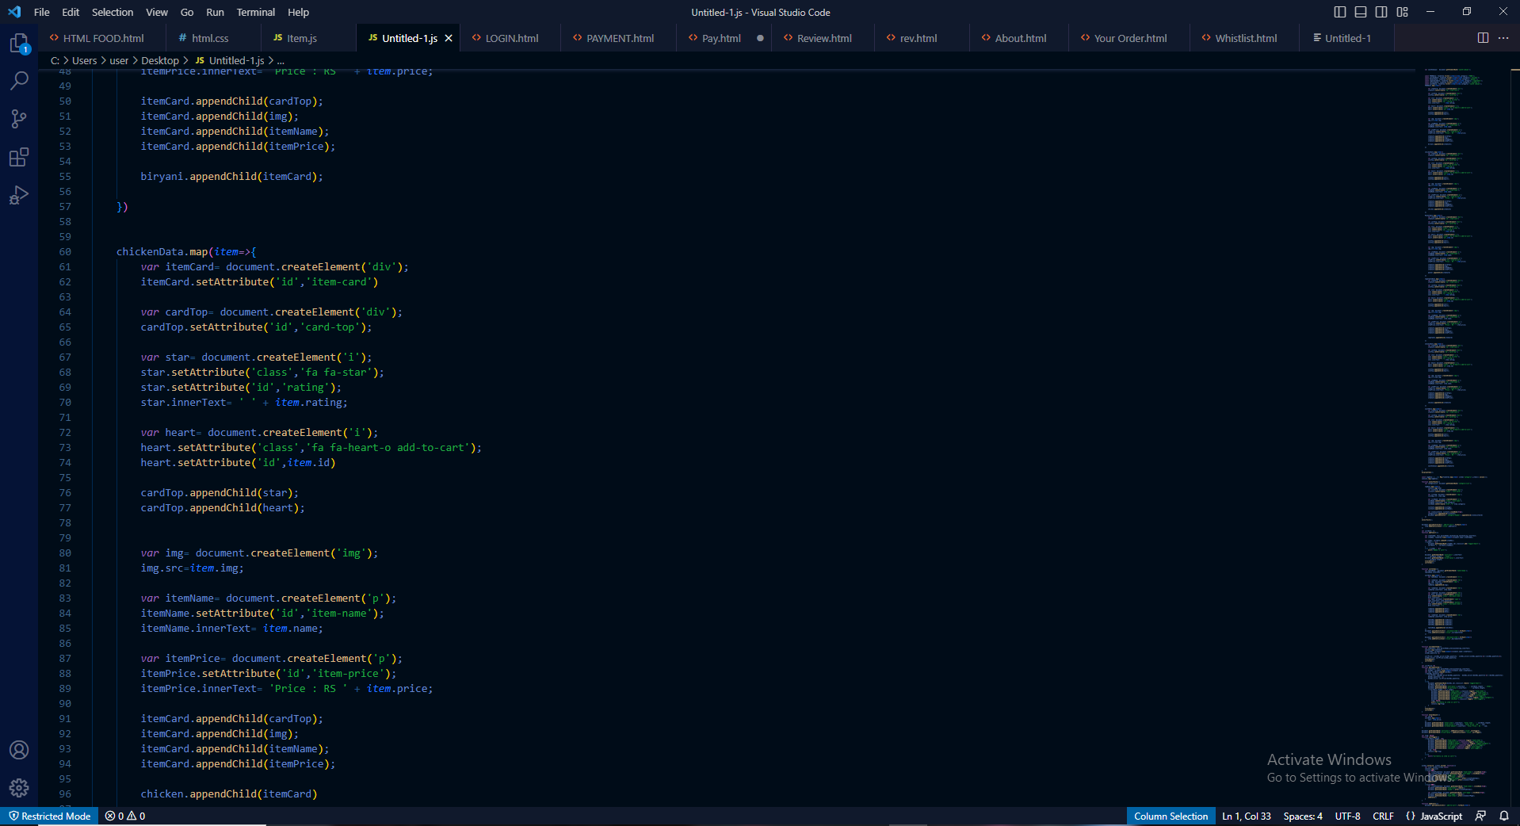

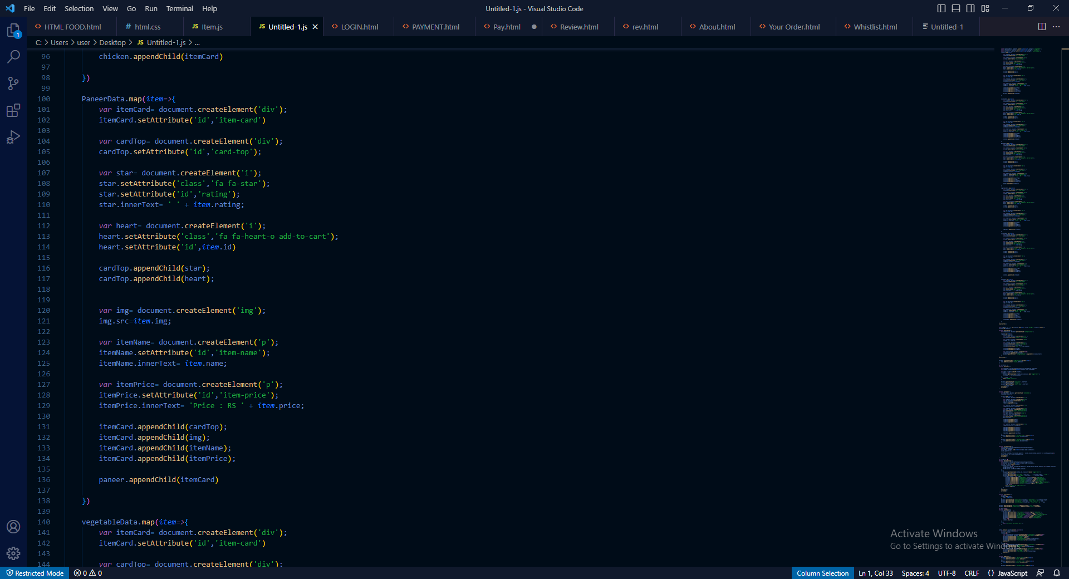

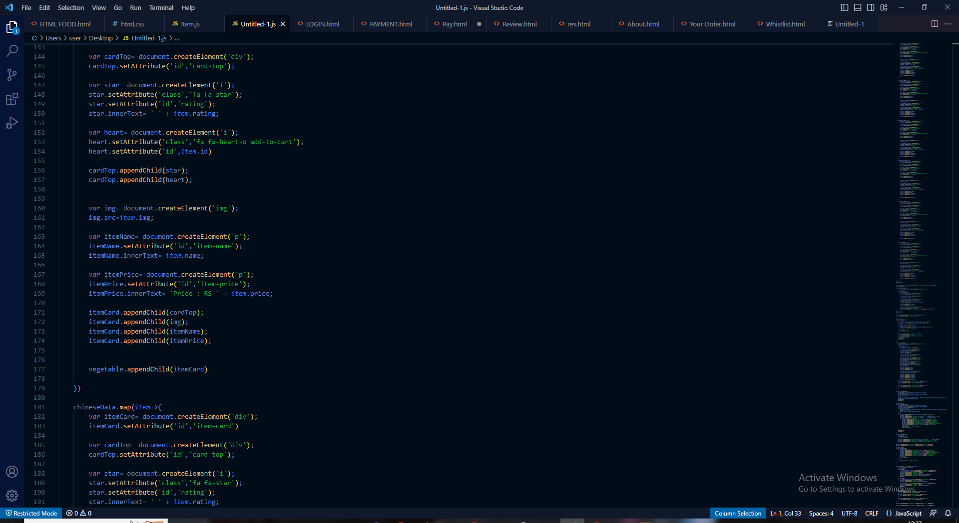

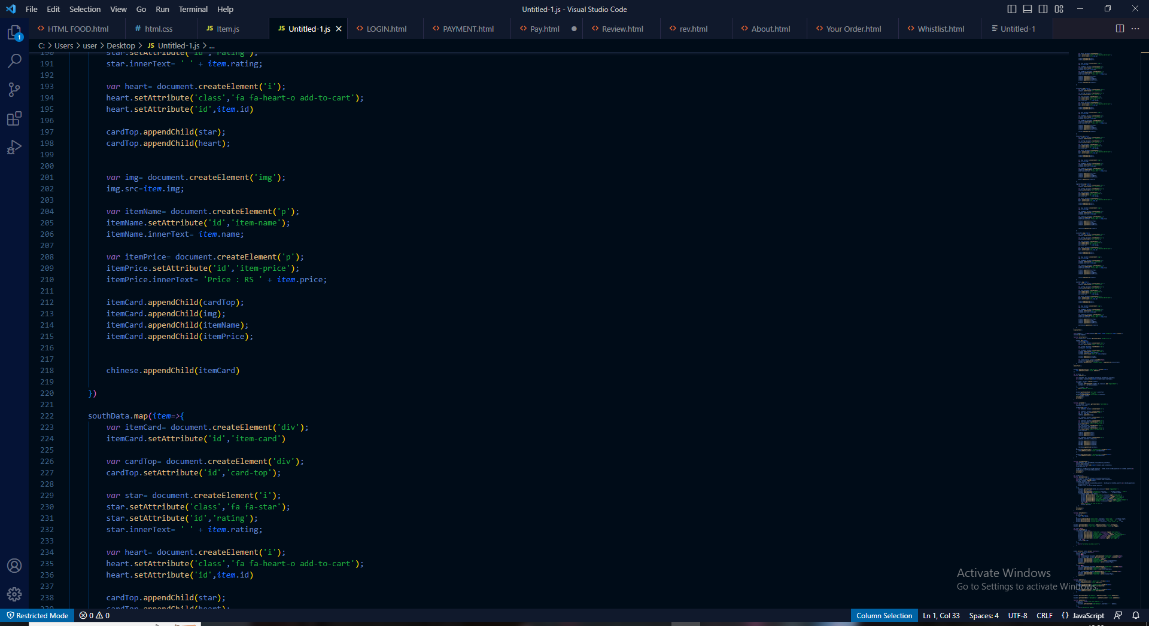

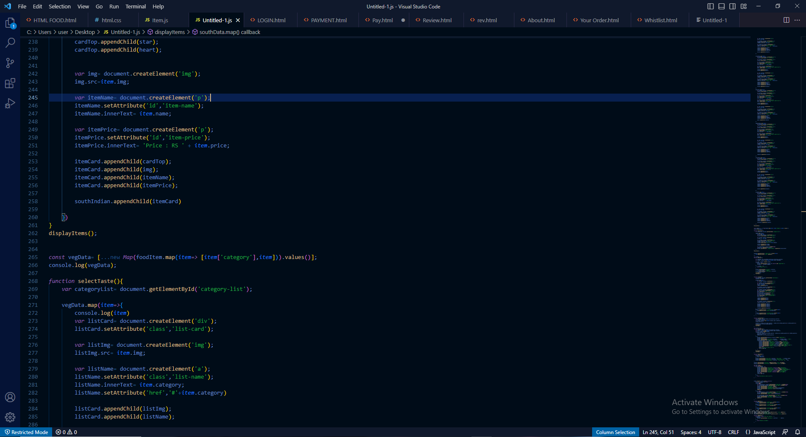

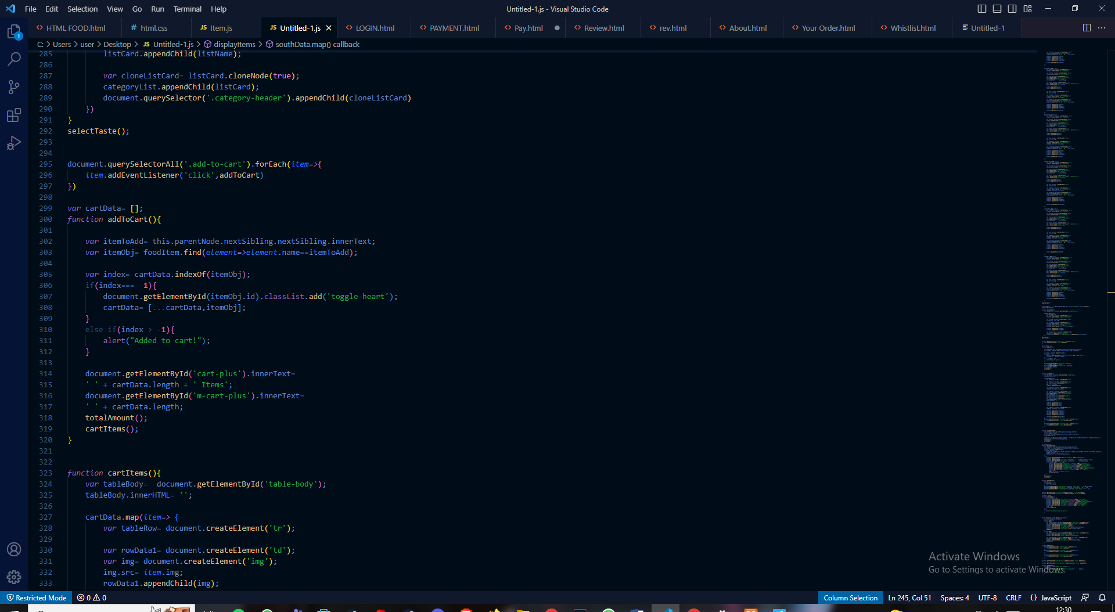

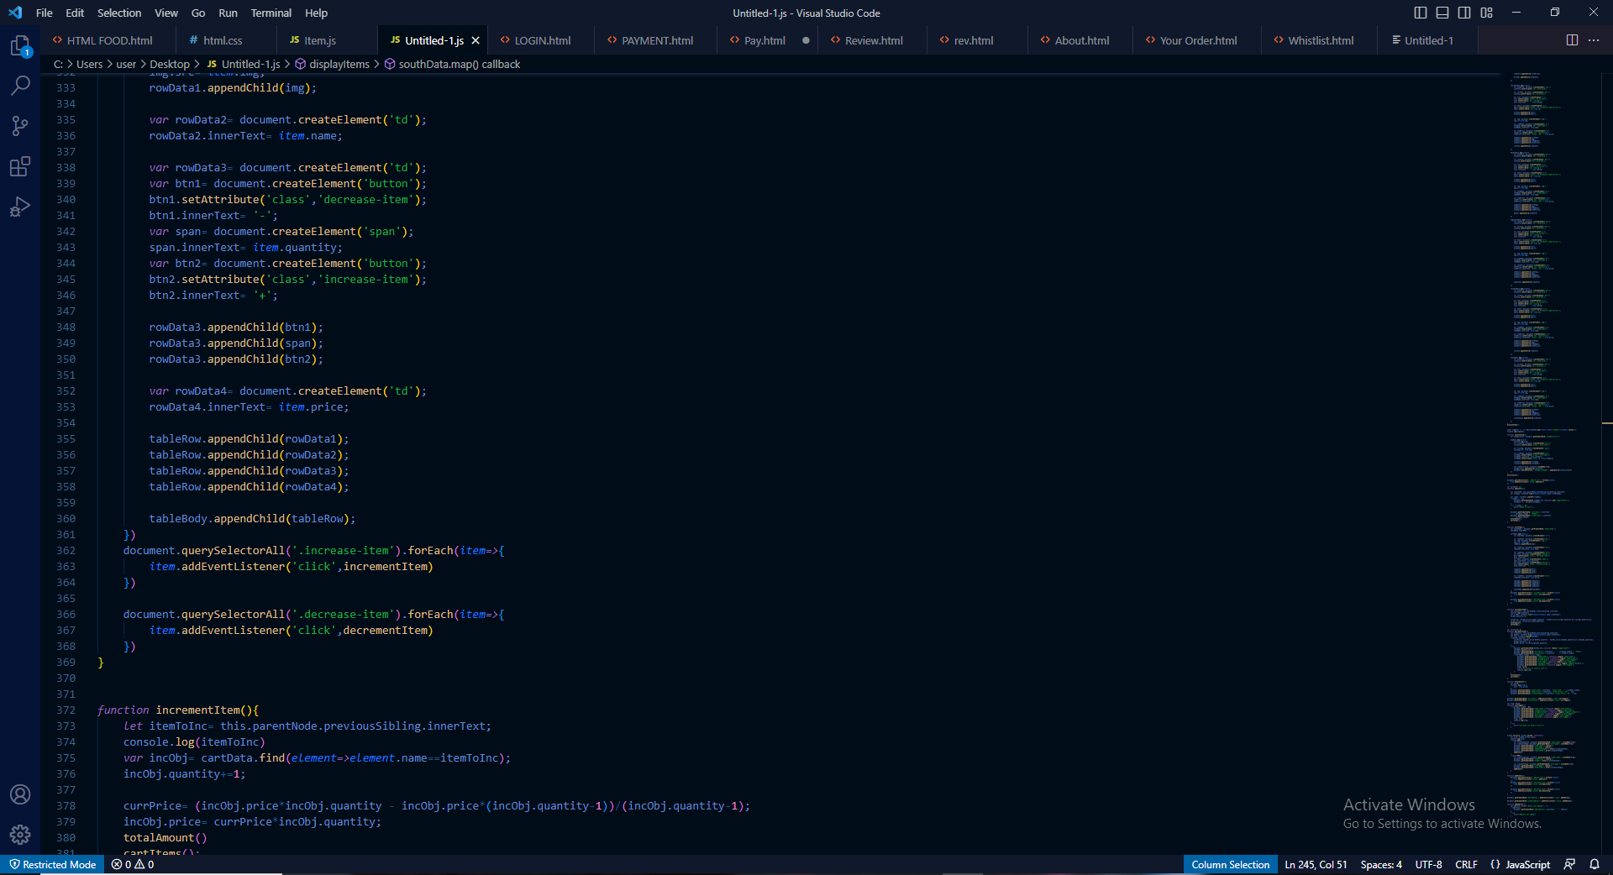

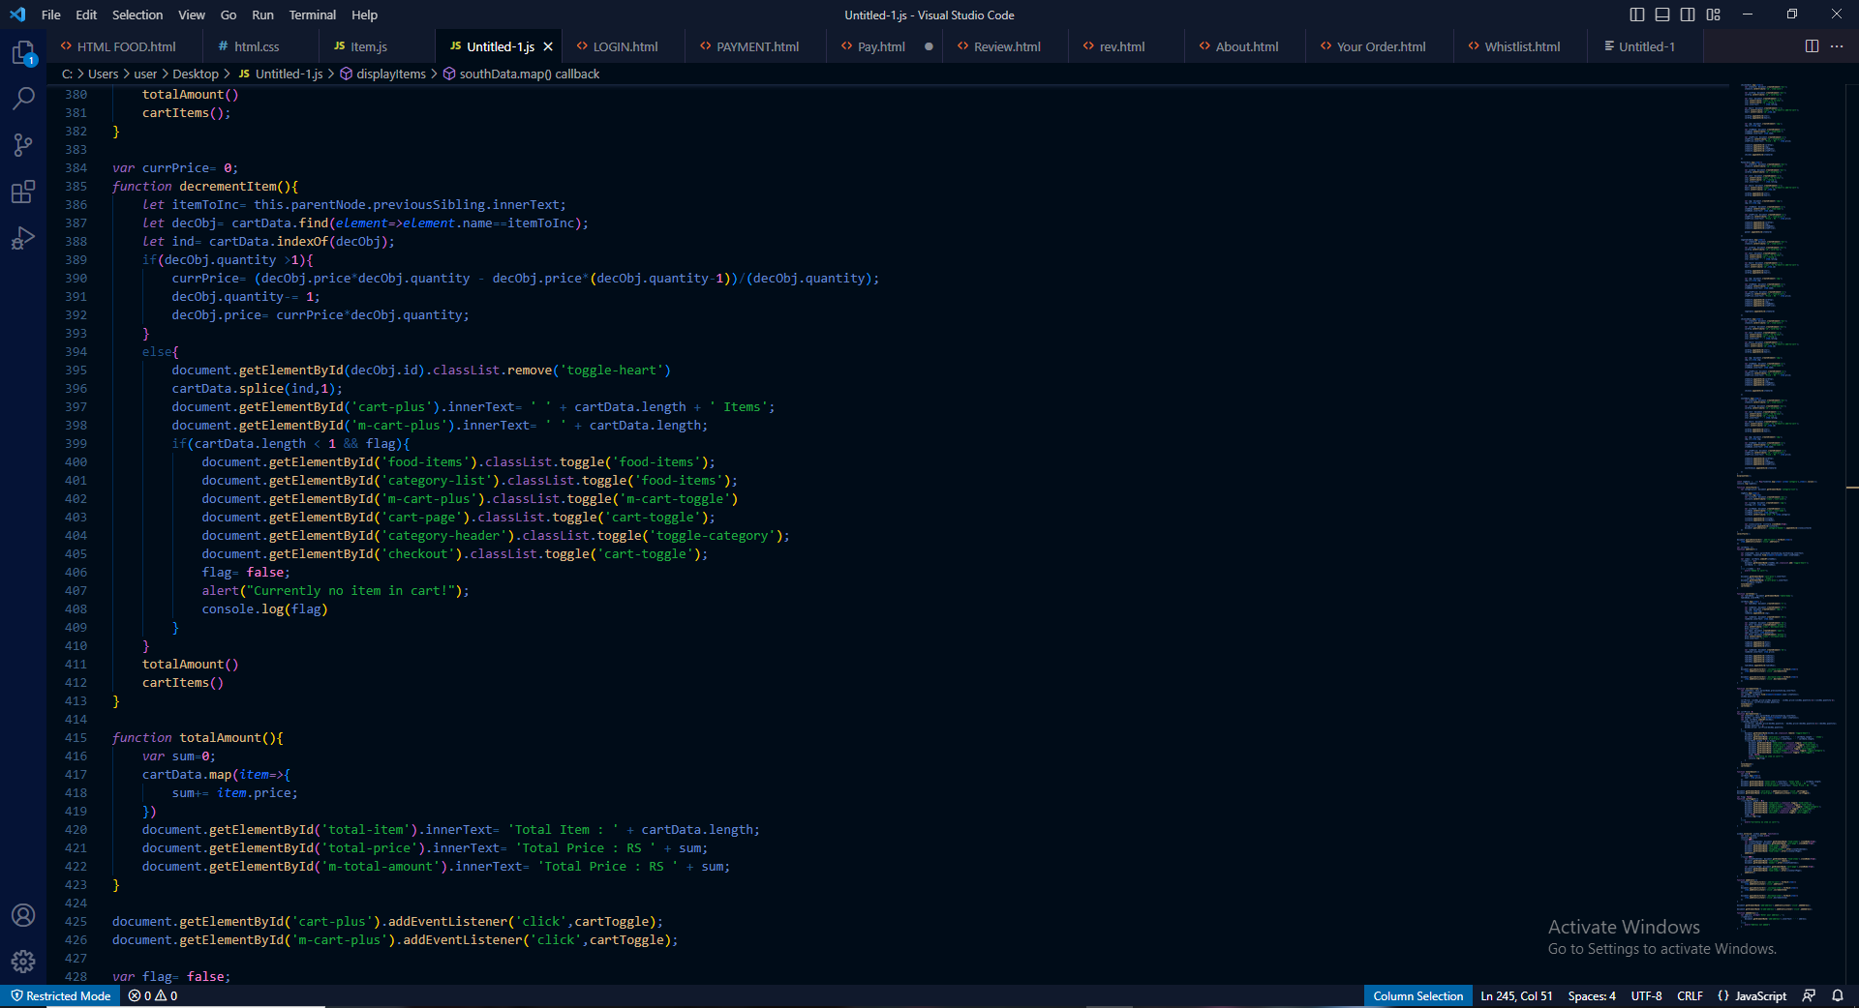

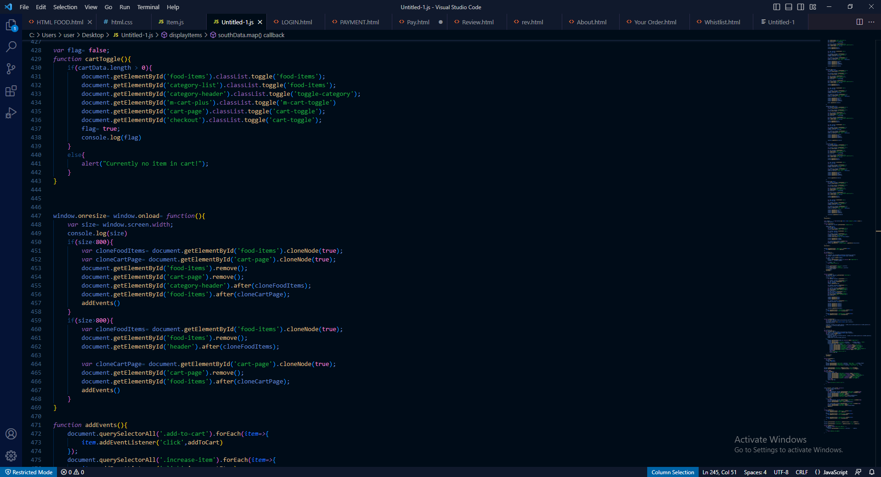

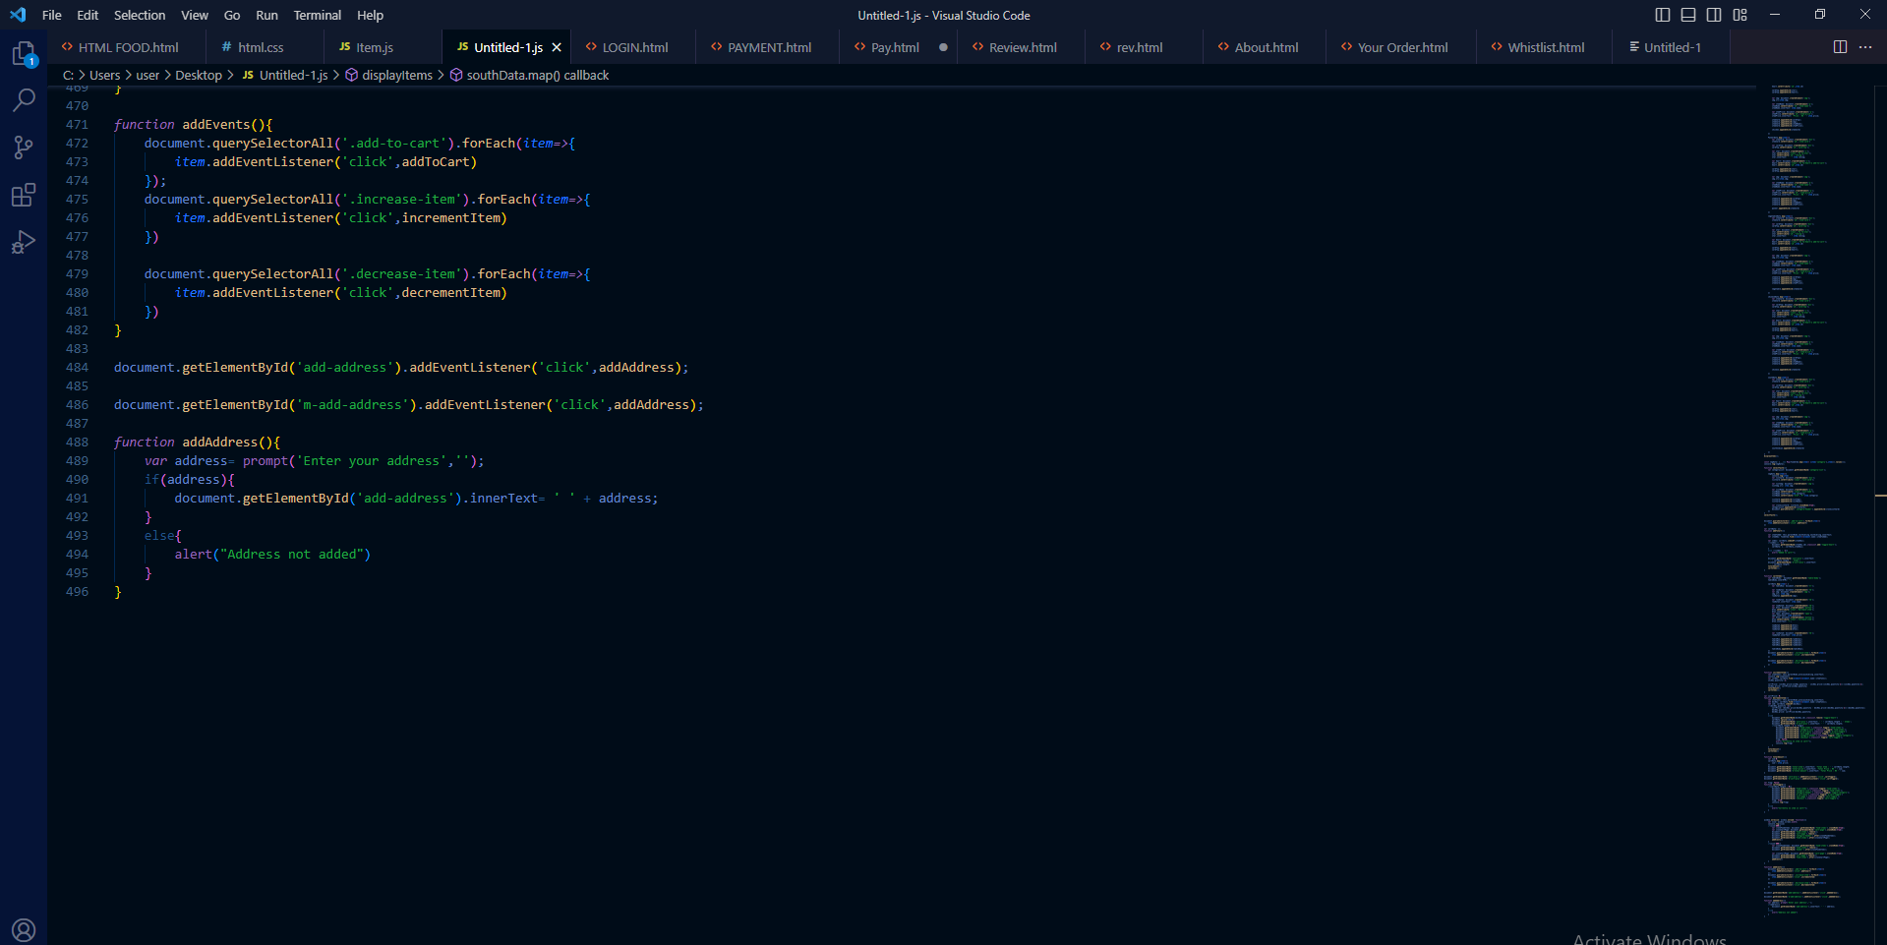

**OUTPUT**

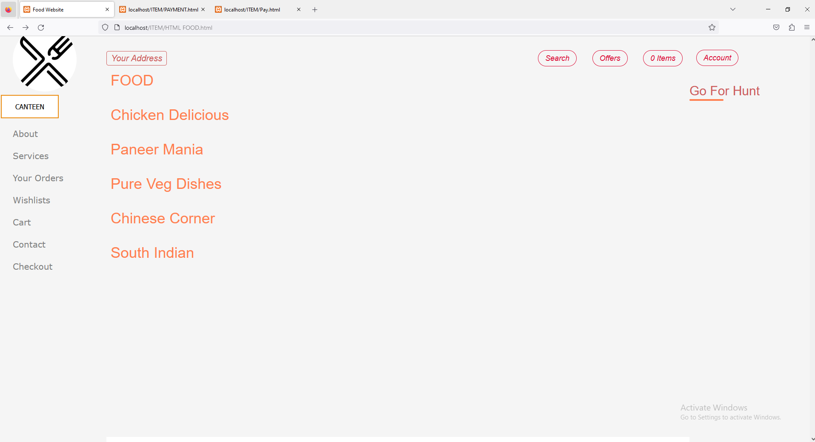

* **Scope**

**A college canteen ordering website can greatly benefit both students and canteen staff. By implementing online ordering, students can save time and avoid long lines, while canteen staff can manage orders more efficiently and reduce wait times. Electronic payment methods can also be implemented, which will reduce the need for cash handling and improve security.**

**The scope of this project would involve designing and developing a user-friendly website that allows students to browse the menu, select items, and place orders. The website should also include features such as order tracking and history, as well as the ability to customize orders or add special instructions.**

**In addition to the website development, the project would also involve setting up the necessary hardware and software infrastructure, as well as training canteen staff on how to use the system.**

**Overall, a college canteen ordering website has the potential to greatly improve the dining experience for both students and canteen staff. By reducing wait times, improving order accuracy, and implementing electronic payment methods, this project can help streamline the canteen's operations and increase customer satisfaction.**

* **Future Scope**

**The future scope of a college canteen ordering website is promising, as advancements in technology continue to improve the way we conduct business and communicate. Here are some potential areas of growth for such a website:**

**Integration with mobile applications: In today's fast-paced world, people prefer to conduct transactions on the go. Integrating the canteen ordering website with mobile applications can provide a convenient and user-friendly experience for students, allowing them to place orders and make payments using their smartphones.**

**Personalized recommendations: By analyzing previous order history and student preferences, the website can provide personalized recommendations to students, making it easier for them to select meals that they are likely to enjoy.**

**Integration with student ID cards: Integrating the website with student ID cards can provide a seamless and secure payment experience**

* **Vision**

**The vision of the college canteen ordering website is to revolutionize the way students order food on campus. We envision a future where students can easily access a wide variety of healthy and sustainable food options through our platform, while also enjoying a more streamlined and efficient food service.**

**Our vision includes using technology to enhance the dining experience, such as by introducing features like pre-ordering, mobile payment, and real-time updates on food availability. We also aim to promote sustainability by encouraging responsible consumption and reducing food waste.**

**Ultimately, our vision is to create a vibrant and inclusive food culture on campus, where students can gather, socialize, and enjoy delicious food while also supporting local businesses and contributing to a more sustainable future.**

* **Mission**

**Our mission is to improve the overall dining experience of students on campus by providing them with a user-friendly platform that offers a wide variety of food options at affordable prices. We aim to simplify the process of ordering food by allowing students to browse menus, place orders, and make payments online. By streamlining the ordering process, we hope to reduce congestion at the canteen and improve the overall efficiency of the food service.**

**We also strive to support local businesses by partnering with small-scale vendors and food suppliers. By promoting local vendors, we aim to create a sustainable and diverse food culture on campus, while also providing students with a wider variety of food options to choose from.**

**In summary, our vision is to create a technology-driven platform that provides students with a convenient and efficient way to order food, while also supporting local businesses and promoting a diverse food culture on campus.**

**PROGRAM EDUCATIONAL OBJECTIVE (PEO)**

**The Program Education Objectives (PEOs) of the college canteen ordering website are as follows:**

**To provide students with a convenient and efficient way to order food from the college canteen, while also improving the overall dining experience on campus.**

**To promote local businesses and vendors by partnering with small-scale food suppliers, thereby creating a sustainable and diverse food culture on campus.**

**To leverage technology to streamline the food ordering process, reducing waiting times and increasing the efficiency of the food service.**

**To enhance students' digital literacy skills by providing them with an online platform for ordering food, which will prepare them for the increasingly digital workplace.**

**To encourage responsible consumption and reduce food waste by providing students with a clear and transparent menu, allowing them to make informed decisions about their food choices.**

**To provide students with an opportunity to provide feedback on the food service, allowing the canteen to improve and tailor its offerings to better meet the needs of the students.**

**Overall, the PEOs of the college canteen ordering website are designed to improve the dining experience on campus while also promoting sustainability, digital literacy, and responsible consumption. By achieving these objectives, we aim to create a positive impact on the overall well-being of the college community.**

**Conclusion**

**In conclusion, a college canteen ordering website has the potential to revolutionize the dining experience for students and canteen staff alike.**

**By implementing electronic payment methods, order tracking, and customization options, the website can save time and increase efficiency for both parties.**

**Additionally, the website can improve customer satisfaction by providing a user-friendly interface and convenient features.**

**The project would require designing a website, setting up necessary hardware and software infrastructure, and training staff.**

**Overall, a college canteen ordering website is a worthwhile investment that can benefit the entire campus community.**

**THANK YOU**

**NAME:- ARNAV CHANDRA RAI**

**ROLL NO:- BCA/45005/20**

**BCA**